

Volunteers For Village Development
Khaivaren Tang, Hungpung
Ukhrul District-795142, Manipur

Annual Report for the period April 2023 -March 2024

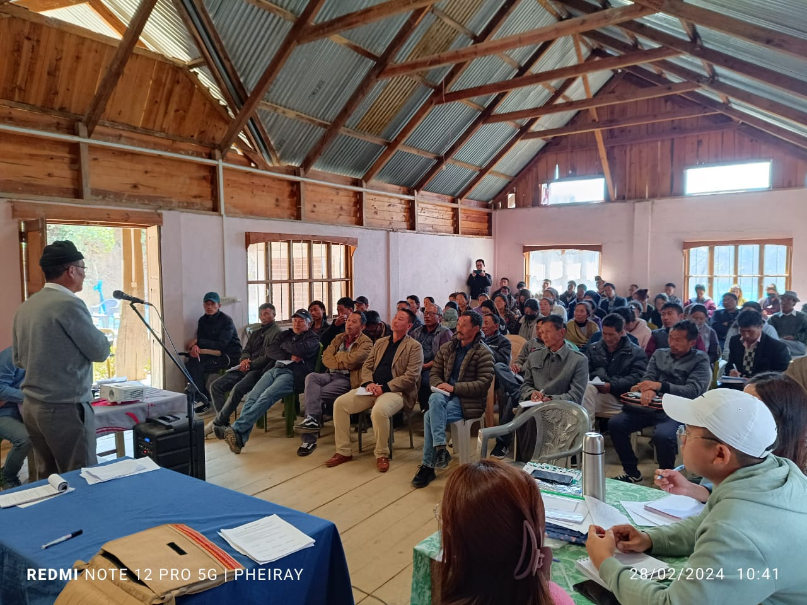

Funders: Bread For The World (Bftw.) Germany
National Bank for Agriculture and Rural Development (NABARD) India,
NECBDC through NEC

Sl. | Content | Page
1 | About the organization and Operational Area | 1
2 | Summary of the Program | 2
3 | Target and Achievement | 3
4 | Activities during the period | 3-7
5 | Challenges and Learning | 8
6 | List of Governing Body and Staffs | 11-12
7 | Activities Photographs | 13-17

Abbreviations:
ADCC- Area Development Coordination Committee
VDC- Village Development Committee
SHG- Self Help Group
L.K ADIO- Lungpha Khukhok Area Development Initiative Organization
RADIO- Raphei Area Development Initiative Organization
IIRDO- Ihang Iril Runrei Development Initiative Organization
SADIO- SAMBU Area Development Initiative Organization

The Volunteers for Village Development (VVD) is a Non-profit Organization working for Community Development. It was formed in 1982 by Retd. Capt. Ashok Y. Tipnis from Maharashtra together with Mr. Tennyson Kazingmei from Lunghar. The organization headquarter is based at Ukhrul.

Geographical Spread
In terms of hand holding support the project works with 42 villages while in terms of capacity building the project works across the district. The project has four field centers known as RADIO, L.K ADIO, IIRDO and SADIO.

Vision
We visualize a society with sustainable livelihood, where love brotherhood and equitable life prevails.

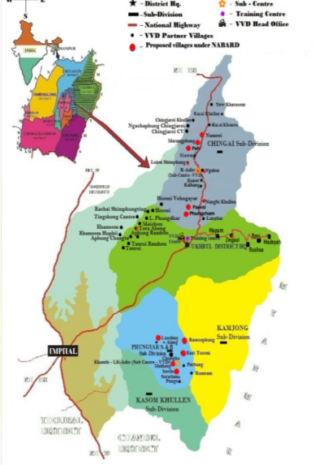
Mission
To enable self Help Initiatives of the people for sustainable livelihood, reducing conflict, liberating from discrimination and enhancing people’s participations in governance.

Operational Area at a Glance

1. | No. of Villages | 42
2. | No. of household | 5,879
3. | Population:
 | Male | 14,996
 | Female | 14,062
 | Total | 29,058

RADIO Villages | L.K ADIO Villages | IIRDO Villages | SADIO Villages
Lunghar  NungbiKhullen  Kalhang  Kuirei  Ngahui  Luireishimphung  Phungcham  Namrei  Razai Khullen  Razai Khunou  ChingjaroiKhullen  ChingjaroiNgachaphung  Chingjaroi C.V  Kharasom C.V  New Kharasom  Peh | Alang  Loushing  Phungyar A  Phungyar B  East Tusom  Chungka  Khambi  Mailiang  Patbung  Kumrah  Shungri  Sorathen  Punge | Hoomi  Maichon  Aheng  Changta  TanruiRamhon  Tanrui  Ngainga  L.Phungdhar | Mapum  Zingsui  Rusheah  Roni  Madoyah

EXECUTIVE SUMMARY

The reporting year April 2023 to March 2024 marked significant progress and transformation across all programmatic areas of Volunteers for Village Development (VVD). In the area of Livelihood, over 845 households were supported through integrated initiatives like land development, kitchen garden expansion, beekeeping, weaving, and horticulture. More than 5,000 fruit tree saplings were distributed across 22 villages, and new training modules on biofertilizer, pest control, and weaving helped communities adopt sustainable, climateresilient practices. Notably, VVD also addressed humanitarian needs by extending food security support to 3,500 displaced persons in Kamjong district.
Under Natural Resource Management, community-led efforts in 13 villages were supported by scientific planning methods such as hydrogeological mapping and catchment surveys. These efforts laid a strong foundation for longterm water conservation and natural regeneration. Community legislation workshops involving 158 participants further empowered local governance structures in managing and protecting shared natural resources.
The NABARD-supported programs stood out for their measurable environmental impact. Through the construction of contour trenches, ponds, brushwood dams, and bunds, the average water discharge rate in project areas increased dramaticallyfrom 1.6 litres per minute (lpm) to 12 lpm. This resulted in a shortened lean season and improved irrigation capacity for local farms and paddy cultivation.
A major development during this period was VVD’s successful onboarding of a new funding partnerAzim Premji Foundation, which will begin supporting longterm programming starting April 2024 for a three-year period. VVD continues to be supported by Bread for the World (Germany), the North Eastern Council (NEC), and NABARD.
Currently in Phase XI of its longterm community development initiative (each phase lasting three years), VVD is actively working in 45 partner villages across Ukhrul and Kamjong districts, reaching thousands of rural households with its integrated programming. Phase XI will conclude in October 2025.
With a people-centric, inclusive, and sustainable approach, VVD remains committed to enabling self-help initiatives and promoting a society where love, brotherhood, and equitable livelihoods prevail.

Organizational Overview

Volunteers for Village Development (VVD) was founded in 1982 by Capt. Ashok Y. Tipnis, a former army officer from Maharashtra, along with his local colleague Tennyson Kazingmei. Established as a people-centered grassroots organization, VVD is registered under the Societies Registration Act and the Foreign Contribution Regulation Act (FCRA). Over the decades, it has grown into a trusted institution supporting rural communities through integrated development programs.
VVD envisions a society with sustainable livelihoods where love, brotherhood, and equity prevail. Its mission is to enable self-help initiatives of the people to redefine their own concept of development based on their unique realities and contexts.
The organization upholds values that govern its daily work and long-term vision: a belief in brotherhood and solidarity with the poor, humility as the foundation of human dignity, and transparency as a pillar for reducing conflict, building trust, and ensuring accountability.
Currently operating in 45 partner villages across Ukhrul and Kamjong districts, VVD’s work spans multiple thematic areas—Livelihoods, Community Capacitation, Women’s Empowerment, Natural Resource Management, and Conflict Mitigation. Although registered as a state-level organization, its work sometimes extends beyond district and state lines, depending on resources and strategic opportunities.
VVD is currently supported by Bread for the World (Germany), the North Eastern Council (NEC), NABARD, and beginning April 2024, by the Azim Premji Foundation. These partnerships enable VVD to continue empowering rural communities through local solutions, institutional strengthening, and climate-resilient development.

Community Capacitation
During the reporting period, significant strides were made in community mobilization and capacity building across multiple partner villages. The Area Development Coordination Committee (ADCC) conducted its 2nd and 3rd quarterly meetings in various locations such as Ngahui, Tanrui, Khambi, L. Phungdhar, and Zingsui, engaging 131 community members in total. These meetings served as vital platforms for village representatives to share progress, deliberate challenges, and reinforce collective responsibility in implementing village development initiatives. Alongside this, Village Development Committees (VDCs) were oriented and trained to update village profiles, leading to increased ownership and databased planning in villages like TanruiRamhon and partner villages under RADIO, LK ADIO, and SADIO. Participatory Rural Appraisal (PRA) exercises and village profile collections were successfully conducted in LamyimPhungdhar and Phungcham villages, resulting in improved participatory planning. Livelihoodfocused training programs were also conducted, covering topics such as livestock management, fruit tree pest and disease control, and beekeeping. These sessions not only enhanced knowledge but also included strong female participation, showcasing a move toward inclusive capacity building. Of particular note was the training on bio-fertilizer making, which reached over 447 participants from 13 villages, reflecting a growing commitment to sustainable agricultural practices.

Livelihood Interventions
The year under review witnessed considerable advancement in sustainable livelihoods through strategic interventions in agriculture, animal husbandry, and vocational training.Land development and minor irrigation initiatives across five villages helped transform unproductive land into cultivable fields Land development efforts reached over 250 families in villages like Peh, ChingjaroiNgachaphung, and Kuirei, enabling enhanced productivity. A total of 5,006 fruit tree saplings were distributed across 22 villages, aiming to diversify income sources and improve household nutrition. Farm fencing support through barbed wire and kitchen garden nets provided protective infrastructure to over 300 families. Beekeeping activities gained momentum, with trainings and box distributions benefiting 84 families in 9 villages, contributing to increased honey production and pollination benefits. Weaving as a livelihood saw focused attention, with 16 women undergoing training and 15 actively engaged in the production unit. Trainings on biofertilizer preparation and pest management further empowered farmers to adopt organic and climateresilient methods. A special humanitarian effort ensured food security for 3,500 refugees from the Burmese refugee camps in Kamjong district. Overall, the livelihood component remained peoplecentric, inclusive, and sustainable.

Natural Resource Management
This year’s natural resource management efforts were deeply rooted in community participation and scientific planning. Tree plantation monitoring was conducted across 13 villages, ensuring accountability and survival of saplings. A three-day workshop focusing on local legislation and community regulation of natural resources was organized for 21 northern villages, engaging 158 participants in policy discourse. In preparation for water conservation structures, preliminary surveys and hydrogeological mapping were carried out in several villages, and technical support was extended to Loushing. These activities laid the foundation for future water conservation works by identifying recharge zones, aquifer potential, and catchment management strategies. Collectively, the initiatives reflected a holistic approach to managing land and water systems in a changing climate.

Conflict Mitigation
Addressing inter-village tensions and promoting peaceful coexistence were core components of the conflict mitigation program this year. A series of strategic meetings and follow-ups were held in conflict-prone areas such as Chingjaroi, Kharasom, and Sorbung, leading to consensus-building and the signing of No Objection Certificates (NOCs) to demarcate village boundaries. This included comprehensive boundary mapping efforts for Punge and Nongman villages involving over 120 participants. Additionally, an intellectual seminar on “Know Your Rights” was organized in Ukhrul, empowering 124 community leaders and youth with knowledge of their legal and constitutional rights. These initiatives have fostered dialogue, reduced tensions, and created pathways for collaborative development.
Women Empowerment
Women’s leadership and participation were significantly amplified through various zonal meets and capacitybuilding seminars. The Tangkhul Shanao Long organized regional meets across the East, West, and South zones, with over 790 women participating actively in community discourses. A oneday seminar in Choithar on women's empowerment attracted 192 attendees, while a similar event later in October further deepened discussions around gender equality, economic participation, and rightsbased approaches. These programs were instrumental in creating spaces for women to voice their aspirations and reinforce their roles in community leadership and decisionmaking.
NABARD-supported Programs
With support from NABARD and cofinancing through own means, extensive watershed development and farmbased initiatives were carried out. Over 3,460 contour trenches were dug across six villages to reduce soil erosion and improve groundwater recharge. Seventeen dugout ponds and eleven brushwood dams were constructed, benefiting multiple farming communities. Farm productivity was enhanced through the distribution of 3,025 lemon saplings and farm fencing materials. Bookkeeping and agricultural training sessions enhanced local capacities in financial management and integrated farming techniques. The project also focused on monitoring and evaluation, with regular field assessments, muster roll verifications, and community interaction. An exposure visit to Imphal, International Women’s Day participation, and geotagging of natural resources in Zingsui and Ngahui reflected the program’s multifaceted approach. Additionally, a twoday training on springshedbased watershed development was organized, further strengthening technical knowledge among field staff and community workers.
Staff Capacitation
Internal capacity building remained a priority, with staff undergoing various thematic and skillbased training sessions. These included workshops on financial literacy for nonfinance staff, climateproofing, pipeline planning for decentralized renewable energy, and robotics in horticulture. Staff also participated in meetings with CSR partners, expanding networking and institutional linkages.

NonMonetary Contributions and Volunteerism
Throughout the year, community members actively engaged in voluntary actions that enriched their environments and supported collective welfare. Activities such as spring rejuvenation, village and roadside cleaning, bamboo plantation, and tree planting were undertaken in at least ten villages. Notably, Razai Khullen’s plantation of over 3,000 native species and Sorathen’s road cleaning initiative exemplified community ownership and environmental stewardship. These nonmonetary contributions reflect the deep-rooted commitment of the communities to sustainable development.

- Community Capacitation
Sl. | Activity | Villages | Date | Participants
 |  |  |  | Male | Female | Total
1 | 2nd ADCC Quarterly Meeting | Ngahui | 18th April 2023 | 17 | 5 | 22
1 | 2nd ADCC Quarterly Meeting | Tanrui | 4th April 2023 | 17 | 2 | 19
1 | 2nd ADCC Quarterly Meeting | Khambi | 4th April 2023 | 11 | 9 | 20
2 | 3rd ADCC Quarterly Meeting | Ngahui | 8th July 2023 | 7 | 2 | 9
2 | 3rd ADCC Quarterly Meeting | L. Phungdhar | 8th July 2023 | 11 | 2 | 13
2 | 3rd ADCC Quarterly Meeting | Khambi | 6th July 2023 | 16 | 2 | 18
2 | 3rd ADCC Quarterly Meeting | Zingsui | 4th July 2023 | 4 | 8 | 12
3 | VDC Orientation  Updating village profile | TanruiRamhon | 5th April 2023 | 4 | 4 | 8
3 | VDC Orientation  Updating village profile | RADIO partner villages | April-June 2023 | 64 | 30 | 94
3 | VDC Orientation  Updating village profile | LK ADIO partner villages | 8th-13th May 2023 | 24 | 9 | 33
3 | VDC Orientation  Updating village profile | SADIO partner villages | 17th-19th May 2023 | 17 | 10 | 27
4 | PRA exercise and Village profile collection | LamyimPhungdhar | 19th -20th May 2023 | 31 | 18 | 49
4 | PRA exercise and Village profile collection | Ngahui, Hoomi, A Changta,TanruiRamhon, Tanrui | 4th -8th May 2023 | 15 | 4 | 19
5 | Training on Livestock Management | East Tusom | 29th May 2023 | 17 | 13 | 41
6 | Training of fruit, tree, pest and disease management | Khambi | 1st April 2023 | 30 | 8 | 38
7 | Two days training on Bee keeping | Khambi | 7th-9th June 2023 | 39 | 9 | 48
8 | Training on making of bio fertilizers | Ngahui | 17th -30th Sept 2023 | 1 | 20 | 21
8 | Training on making of bio fertilizers | Razai Khunou | 17th -30th Sept 2023 | 3 | 20 | 23
8 | Training on making of bio fertilizers | Kharasom CC | 17th -30th Sept 2023 | 1 | 32 | 33
8 | Training on making of bio fertilizers | New Kharasom | 17th -30th Sept 2023 | 10 | 13 | 23
8 | Training on making of bio fertilizers | Razai Khullen | 17th -30th Sept 2023 | 6 | 35 | 41
8 | Training on making of bio fertilizers | C. Ngachaphung | 17th -30th Sept 2023 | 4 | 55 | 59
8 | Training on making of bio fertilizers | Chingjaroi C. V | 17th -30th Sept 2023 | 4 | 31 | 35
8 | Training on making of bio fertilizers | A Changta | 17th -30th Sept 2023 | 7 | 24 | 31
8 | Training on making of bio fertilizers | Aheng | 17th -30th Sept 2023 | 6 | 30 | 36
8 | Training on making of bio fertilizers | Maichon | 17th -30th Sept 2023 | 2 | 21 | 23
8 | Training on making of bio fertilizers | Sub Total |  | 44 | 281 | 325
9 | ADCC Meeting | RADIO | 6th Oct. 2023 | 12 | 6 | 18
10 | PRA exercise | Phungcham | 14th Oct 2023 | 28 | 11 | 39
11 | Collection of Village profile | Phungcham, Namrei, Nungbi Razai Khullen | 30th Oct, 1st, 11th, 13th Nov 2023 | 13 | 8 | 21

- Livelihood
Sl. | Activity | Villages | Date | Families Covered
1 | Land development | Peh, ChingjaroiNgachaphung, Kuirei | 5th -12th May, June 2023 | 63 (8+48+7)
2 | Distribution of 5006 saplings | Hoomi, A Changta, Tanrui, TanruiRamhon, Namrei, Chingjaroi CV, Ngachaphung, Razai khullen, Phungcham, A Changta, Tanrui, Alang, Loushing, East Tusom, Phungyar, Chungka, Khambi, Mialiang, Kumram, Patbung, Sorathen, Punge | 16th April, May, June 2023 | 602
3 | Transportation of barbed wire for Farm fencing | Zingsui | 18th April 2023 | 52
4 | Procurement and distribution of kitchen garden net | Ngahui, Razai Khunou, Kharasom CC, New Kharasom, Razai Khullen, C. Ngachaphung, Chingjaroi C. V, A Changta, Aheng, Maichon | 18th July, 17th sept. – 30th Sept. 2023 | 287
5 | Bee keeping | Punge, Sorathen, Khambi, Chungka | 9th June 2023 | 31
6 | Training on Weaving | VVD training center | April-Sept 2023 | 16 trainees
7 | Weaving production | VVD training center | April-Sept 2023 | 15 women in production unit
8 | Piggery | Lunghar | - | 1 unit
12 | Land development and Minor irrigation | Kuirei | Dec 2023 | 5
12 | Land development and Minor irrigation | TanruiRamhon | Jan-March 2024 | 13
12 | Land development and Minor irrigation | Razai Khullen | Jan-Feb 2024 | 19
12 | Land development and Minor irrigation | Ngachaphung | Jan-March 2024 | 135
12 | Land development and Minor irrigation | A Changta | Jan-March 2024 | 15
13 | Community mobilization for ground work preparation of MI | Mapum, Rusheah | 23rd -25th Jan, 5th -7th Feb 2024 | 15
14 | Meeting and Monitoring of MI, Land Development | Mapum, Rusheah,Changta, TanruiRamhon, Peh | 21st -22nd March 2024, 15th -16th Jan. 2024 | 46
15 | Re-Verification and Site Selection for Check Dam Construction | Rusheah | 25th -26th March 2024 | 3
16 | Training on making of bio fertilizers | Tanrui, TanruiRamhon, Hoomi | 11th sept. – 13th Oct. 2023 | 68
17 | Distribution of 1307 Apple saplings | Madoyah, Zingsui, Roni, Mapum, Zingsui, Rusheah, Punge, Aheng, Maichon, Lunghar. Chingai, Tusom CV, Kuingai, TusomKhullen | 23rd -25th Jan, 2nd, 6th -7th Feb 2024 | 209 household
18 | Monitoring of Fruit saplings | Mapum, Zingsui, Rusheah, Roni, | 23rd -25th Jan 2024 | 155 household
19 | Training on Bee keeping and distribution of bee boxes | Zingsui | 22nd -23rd March 2024 | 16
19 | Training on Bee keeping and distribution of bee boxes | Phungyar, Chungka, Loushing | 11th -12th March 2024 | 22
19 | Training on Bee keeping and distribution of bee boxes | A. Changta | 7th Feb. 2024 | 15
20 | Monitoring of bee boxes | Chungka, Punge, Sorathen | 29th Feb-1st March 2024 | 25
21 | Garden Net for fencing kitchen garden | Tanrui | 11th to 13th Oct. 2023 | 25
21 | Garden Net for fencing kitchen garden | TanruiRamhon | 12th Oct 2023 | 20
21 | Garden Net for fencing kitchen garden | Hoomi | 13th Oct 2023 | 20
22 | Monitoring of kitchen garden, apple saplings, avocado seeds and lemon saplin1gs | Nungbikhullen, Ngahui, Kharasom CC, New Kharasom, Chingjaroi C.V, ChingjaroiNgachaphung | 22nd to 24th November
23 | Food security for refugees of displaced families in Kamjong District | Kheronram and Phaikoh Burmese Refugee camp | 14th Feb 2024 | 3500
24 | Weaving training | VVD training centre, NTNBA centre | Oct 2023-March 2024 | 20
25 | Piggery | Somdal, Lunghar | 19th March 2024 | 2

2.1 List of families covered under Land development and Minor irrigation
Sl.no. | Village | Beneficiaries
1 | ChingjaroiNgachaphung | RK. Phanitphang | SK. Aningpa | T. Panamla | R. Sovi
1 | ChingjaroiNgachaphung | R. Cleanse | SK. Joshua | M. Chirmi | M. Soya
1 | ChingjaroiNgachaphung | C. Wise | R. Masotyang | R. Linpa | RK. Thuingam
1 | ChingjaroiNgachaphung | R. Ramkahao | R. Vidan | SK. Viso | Shangvinah
1 | ChingjaroiNgachaphung | R. Happyson | AS. Ruichumhao | T. Thotmathing | M. Chihanpam
1 | ChingjaroiNgachaphung | SK. Nelson | AS. Tomba | R. Themreiso | R. Ningon
1 | ChingjaroiNgachaphung | SK. Vaomi | M. Jano | M. Angrandi | Canneleus
1 | ChingjaroiNgachaphung | M. Ramyo | R. Thanmi | M. Eliso | K. Huimi
1 | ChingjaroiNgachaphung | R. Pemmi | Rathing | M. Shimrei | SK. Mahai
1 | ChingjaroiNgachaphung | Somaya AS | R. Krilo | T. Asew | SK. Angrandi
1 | ChingjaroiNgachaphung | R. Khachung | K. Joyson | R. Ngayarmi | M. Visoni
1 | ChingjaroiNgachaphung | RK. Kapuni | T. Varepam | RK. Machung | R. Khalelew
2 | Peh | R.S Kapangsing | R.S Khanmichon | R.S Mingmayang | R.S Thangmeiso
2 | Peh | R.S Phanitla | R.S Nganingkhui
3 | Kuirei | ShimpamZingkhai | Z. Ringphami | Z. Ramkating | Z. Ramyo
3 | Kuirei | R.S Thuingaleng | R. Reubin | K. Hopeson

2.2 List of villages for sapling distribution
Sl. | Villages | No of individuals covered | No of seeds and saplings distributed
Sl. | Villages | No of individuals covered | Apple | Avocado | Lemon
1 | Mailiang | 22 | 198 | 0 | 220
2 | Sorathen | 20 | 114 | 0 | 200
3 | Punge | 19 | 95 | 0 | 0
4 | Khambi | 7 | 224 | 0 | 100
5 | East Tusom | 16 | 84 | 0 | 283
6 | Kumram | 55 | 224 | 0 | 0
7 | Chungka | 2 | 0 | 100 | 200
8 | Alang | 38 | 240 | 0 | 0
9 | ChingjaroiNgachaphung | 113 | 200 | 0 | 0
10 | Chingjaroi CV | 24 | 243 | 0 | 0
11 | NungbiKhullen | 7 | 0 | 380 | 0
12 | Razai Khullen | 79 | 184 | 327 | 0
13 | Tanrui | 91 | 130 | 390 | 240
14 | TanruiRamhon | 36 | 0 | 186 | 80
15 | Hoomi | 68 | 0 | 0 | 67
16 | A Changta | 43 | 0 | 0 | 135
17 | Mapum | 6 | 10 | 10 | 20
18 | Zingsui | 9 | 10 | 15 | 10
19 | Rusheah | 25 | 30 | 30 | 70
20 | Roni | 28 | 55 | 50 | 50
21 | Madoyah | 18 | 50 | 50 | 112
22 | Punge | 25 | 20 | 20 | 45
23 | Aheng | 2 | 25 | 25 | 100
24 | Maichon | 76 | 50 | 50 | 80
25 | Lunghar | 16 | 0 | 0 | 100
 | TOTAL | 845 | 2186 | 1633 | 2112

2.3. List of weaving trainees
Name of trainees
Chonchuila | Vita | Chanmila | A.S Pamyo | Sopemla
Lemya | Sosowon | Sosemphy Horam | Soreiwon | Yarmichon
Philayo | Rintharwon | Soyaphy | Singmichon | Sonam
Soyao
2.4 List of weavers who are engaged in production
Name of weavers in production
ThotraniShimray | RinthinglaZimik | Yarmila | Angel | Wontimla
RinyamiKhamrang | RamyaolaZimik | Shangreiphy | Wungshungmi | Ngathingchon
Naomiwon | Ningreiwon | Wungtimla | Rawon | NG. Priya
Ningchipem | Thingreila | Soyaola | AS Rose | Pamyaola
Wormichon | Rintharwon | M. Sorormi | Wonmila | Hannah
Ningrumla | Chihanwon | Kanmila | Philayo | Siningla
Sotim | Soyaphi
 | - Natural Resource Management
Sl. | Activity | Village | Date | Male | Female | Total
1 | Monitoring of tree plantation | Chingjaroi CV, New Kharasom, Razai Khunou, Phungcham, Ukhrul, KhamasomPhungrei, Marangphung, Kalhang,Nungbi | April-May | 5 | 3 | 8
2 | NRM workshop for regulating strengthening legislation on use of Natural Resources | 21 villages of North | 26th-28th Feb 2024 | 94 | 64 | 158
3 | Monitoring of tree plantation | KhamsomPhungdhar, KhamasomPhungrei, Kuirei, Phungcham | 15th -16th March 2023 | 9 | 1 | 10
4 | Preliminary survey for water conservation | Peh and Phungcham | October 2023
5 | Hydrogeological mapping | Sorathen, Mailiang, Khambi | 11th -12th Oct 2023, Feb 2024 | 9 | 0 | 9
6 | Technical support for water conservation | Loushing | 29th Feb 2024 | 10 | 0 | 10

 | - Conflict Mitigation
Sl. | Activity | Villages | Date | Participants
 |  |  |  | Male | Female | Total
1 | Meetings on conflict mitigation | Chingjaroi and Kharasom | 6th May 2023 | 27 | 0 | 27
2 | Follow up of village boundary mapping for Punge and Signing of NOC with its neighbouring villages | SorbungNongmanSorathen, Sorde, Maiwai | 19th -22nd, 28th -29th April 2023 | 59 | 3 | 62
3 | Boundary Mapping and Signing of NOC Agreement for Nongman village | Kumram, Patbung, Mailiang, Sorde, Sorathen, Punge, Sorbung, Maiti | 3th -6th, 9th -12th May 26th- 27th Sept 2023 | 62 | - | 62
4 | One day intellectuals and community leader’s seminar on Know your Rights | Ukhrul | 26th April 2023 | 74 | 50 | 124

 | - Women Empowerment
Sl. | Activity | Place | Date | Participants
 |  |  |  | M | F | Total
1 | Tangkhul Shanao long Zonal meet for East Zone | ShangshakPhunghon Village | 11th – 13th September 2023 | - | 152 | 152
2 | Tangkhul Shanao long Zonal meet for West | Tallui | 25th -27th September 2023 | - | - | 140
3 | Tangkhul Shanao long Zonal meet for South | KasomKhullen | 19th -21st September 2023 | - | - | 350
4 | One day seminar for Women Empowerment | Choithar | 16th Sept 2023 | 61 | 131 | 192
5 | Tangkhul Shanao long Zonal meet | NungbiKhullen | 4th – 6th October | 8 | 142 | 150
6 | Seminar on Women empowerment | Choithar | 16th Oct. 2023 | 97 | 109 | 206

- Programs implemented under NABARD (Own means contribution)
Sl | Activities | Village | Date | Participants
 |  |  |  | M | F | Total
1 | Digging of 500 contour trenches | Nungbi | April –May 2023 | 18 | 6 | 24
2 | Digging of 1800 contour trenches | Kalhang | April-May 2023 | 78 | 56 | 134
3 | Digging of 1163 contour trenches | Luireishimphung, Kuirei and Ngahui | April-May 2023 | 214 | 168 | 382
4 | Construction of 4 dug out ponds | Kalhang, | 17th -26th April 2023 | 4 | - | 4
4 | Construction of 5 dug out ponds | Nungbi | 5th -12th April 2023 | 5 | - | 5
5 | Construction of 8 dug out ponds | Kuirei, Ngahui, Luireishimphung | April 2023 | 8 | - | 8
6 | Construction of 4 brush wood dam | Kalhang | May 2023 | 9 | - | 9
7 | Construction of 7 brush wood dam | Ngahui, L.Shimphung | May 2023 | 19 | - | 19
8 | Construction of 1 contour bunding | Nungbi | 17th – 19th June 2023 | 8 | - | 8
9 | Construction of 2 bench terrace | Ngahui | 18th April 2023 | 2 | - | 2
10 | Construction of 1 water channels | Kalhang | 17th – 5th May 2023 | 6 | - | 6
11 | Distribution of 3025 Lemon saplings | Ngahui, Kuirei, Nungbi, KalhangLshimphung | May-June 2023 | 240 families
12 | Distribution of Barbed wire for farm fencing | Kalhang and Nungbi | 26th June 2023 | 18 | - | 18
13 | 2 days Book Keeping training | Ngahui,Kuirei and Luireishimphung | 19th -20th July 2023 | 6 | 19 | 35
14 | Training on Crop diseases, Pest control and Soil management | Kuirei, Luireishimphung and Ngahui | 21st July 2023 | 32 | 36 | 68
15 | Monitoring of Community barbed wire fencing and individual farm fencing and plantation of lemon saplings | Kalhang | 1st -3rd August 2023 | 8 | - | 8
16 | Preparation of case study | Kalhang | 2nd August 2023 | 6 | 2 | 8
17 | Collection of Muster roll for lemon plantation, tree plantation, fencing and construction of brushwood dam, monitoring of project activities. | Kalhang | 17th -18th August 2023 | 13 | - | 13
18 | 3,660 Oak seed plantation | Kalhang, Nungbi | June, Sept. 2023 | Community
19 | NGO meet cum exposure visit of partner institution of NABARD | Imphal | 12th-13 Jan 24 | 2 | 0 | 2
20 | Geo Tagging of Kha Leiyor shim | Ngahui, Zingsui | 15th Feb, 2024 | 3 | 0 | 3
21 | Participated International Women’s Day | Imphal | 8th March | 0 | 2 | 2
22 | Meeting with GM, NABARD | Imphal | 17th March 24 | 2 | 0 | 2
23 | Income assessment, rating and monitoring of SHGs project activities | NungbiKhullen | 21st March 2024 | 0 | 41 | 41
24 | Two-day training program on Springshed based watershed development project | Machi | 16th – 17th Feb 24 | 0 | 2 | 2

9. Staff Capacitation

Sl. No | Activities | Date | Villages | Participant
1 | Workshop on Finance for non-finance organized by FMSF | 26th -27th April 2023 | Imphal | 3 |  | 3
2 | Program Orientation for new staffs | 12th June 2023 | VVD, Board room | 5 |  | 10
3 | Workshop on “building program for pipelines for DRE for livelihoods in North East Region | 21st – 23rd September 2023 | Guwahati | 1
4 | Workshop on Climate Proofing | 26th – 27th Sept. 2023 | Online | 2
5 | Meeting with Asst. Director(H) and General Manager (National Insurance) | 4th – 5th Sept. 2023 | Imphal | 1
6 | Training of field worker of NGOs on hands on Robotics & drone application in Horti. crops | Imphal | 29th Jan 2024 | 2
7 | Annual CSR Event | Delhi | 6th -7th March 2024 | 2

8. Non-Monitory participation
Sl. No. | Activities | Village | Month | Specification
1 | Cleaning of Village Compound and springs | Razai Khunou | 7th April, 9th Sept 2023 | Cleaning of village compound and 2 springs in 2 localities
2 | Tree plantation | Razai Khunou | 5th August 2023 | Planting of evergreen tree saplings
3 | Digging of springs | New Kharasom | 30th Sept. 2023 | Digging of 1 spring
4 | Bamboo plantation, cleaning of village surroundings | Chingjaroi CV | 6th July 2023 | Bamboo plantation, Weeding, cleaning of plastics done within the village vicinity
5 | Community tree plantation | Razai Khullen | 1st July 2023 | Planted 3000 nos. of oak, wild olive, and local species
6 | Cleaning of village compound | Ngachaphung | 1st June, 5th August 2023 | Weeding
7 | Weeding of Inter village Road | Sorathen | August 2023 | Cleaning the inter village highway between Shungri and Sorathen
8 | Road clearance from village to paddy field | Nov 2022 | Roni | Whole village
9 | Road singling from ChingjaroiKhullen to Razai Khunou | Jan 2023 | Chingjaroi and Razai Khunou | 70

Challenges:
Despite notable progress across programmatic areas, the reporting period was not without its challenges. One of the persistent internal issues faced was staff turnover due to low remuneration, making it difficult to retain skilled personnel for long-term community engagement. The organization continues to explore alternative strategies to build staff motivation and improve retention within available means.
In the area of natural resource management, a major challenge arose due to the parallel implementation of the government’s Jal Jeevan Mission. To prevent overlapping efforts, the originally proposed budget for water conservation had to be reallocated. However, this realignment created a gap at the village level where government execution did not fully meet the expected outcomes, thereby affecting the continuity and impact of planned water conservation interventions.
Community-level conflicts also posed obstacles to smooth implementation. The emergence of new power centres and competing local leadership structures challenged the traditional authority of the village king and his council, leading to resistance and delays in consensus-building. Additionally, conflicting interests in community priorities often led to demands for changes in agreed project plans, requiring negotiation and adaptation mid-implementation.
Geographic inaccessibility further compounded these issues. Several partner villages are only motorable for about six months a year due to terrain and weather conditions, limiting timely delivery of resources, monitoring, and follow-ups.
Lastly, residual impacts of the COVID-19 pandemic continued to be felt. Seasonal activities such as community tree plantation were significantly disrupted due to lingering health concerns and social restrictions, affecting both participation levels and implementation timelines.
These challenges underscored the importance of adaptive planning, deeper community engagement, and strategic coordination with government programs. Going forward, VVD aims to strengthen its conflict mediation mechanisms, enhance stakeholder dialogue, and invest in more resilient implementation models.
Lessons learned
- The system of data entry can be improved by developing a dashboard and maintaining a database of each beneficiary.
- Working on one specific issue at a time to make significant change in the community rather than focusing on multiple issues.
- Continuous skill enhancement of staff in different field to strengthen the experiences gain in the field for mitigating challenges in the field in areas of conflict mitigation, Analysing skills, reporting and documentation.
List of Governing Body Members | Sex | Designation | Background
Mrs. Janeth Hungyo | F | Chairperson | Academician
Rev. M. Luiram | M | Vice Chairman | Priest
Mr. Jubilate Kazingmei | M | Secretary | Social Work
Mr. Shangreingam | F | Treasurer | Area committee Chairman, LK ADIO
Mr. Ephraim Shaiza | M | Member | Priest
Mrs. G.S Yaopeila | F | Member | Health Worker
Mrs. Grace T. Shatshang | F | Member | Social Activist
Mr. K. Gemson | M | Member | Lawyer
Mr. PS. Vareichung | M | Member | Area committee Chairman, SADIO
Mr. VareisoVashum | M | Member | Area committee Chairman, RADIO

List of Staffs Administration
Names | Sex | Designation
K. Pamlei | M | Manager, Finance
ShangshingMungkung | F | Accountant
T. Puni | M | Cashier
Dr. Depend Kazingmei | M | Manager, Admin
K. Tuimi | F | Sr. Office Assistant
K. Ngachon | M | Chawkidar
PhilachonRaingam | F | Office Assistant

List of Program Staffs
Names | Sex | Designation
Jubilate Kazingmei | M | Program Director
Ramyik Pheiray | M | Program Manager
Rinsophy Asai | F | Field staff, Ukhrul district
WorleichonLuithui | F | Field staff, Kamjong district
KhanreiyoKazingmei | M | Technician
Dr. WeyepeN Mekrishu | M | Technical officer
ThanksonMuinao | M | Field staff, Ukhrul district
Minao Mangkung | M | Field staff, Kamjong district
YurshimKazingmei | M | Field staff, Ukhrul district
Pasoulo N | M | Horticultarist
M. Ngayeimi | M | Training instructor
T. Silas | M | Sr. Driver
T. Rovi | M | Driver
Sunil Kotwal | M | Driver

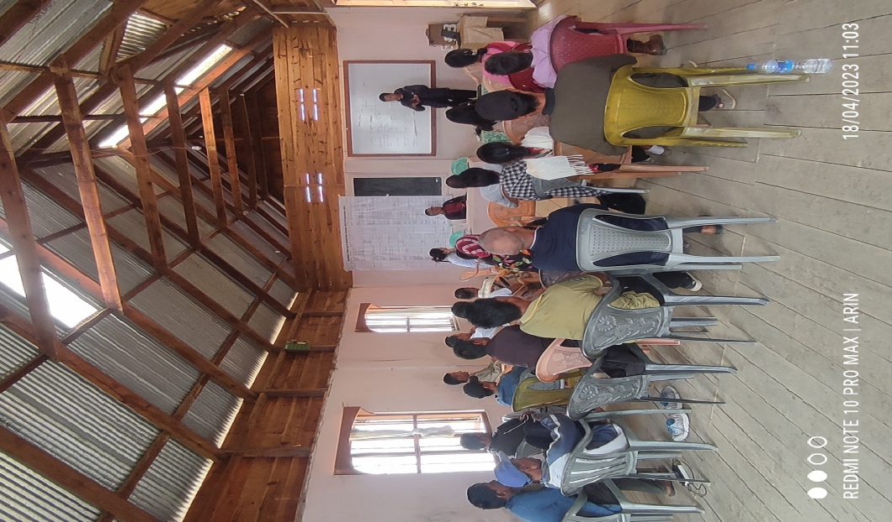
Photographs

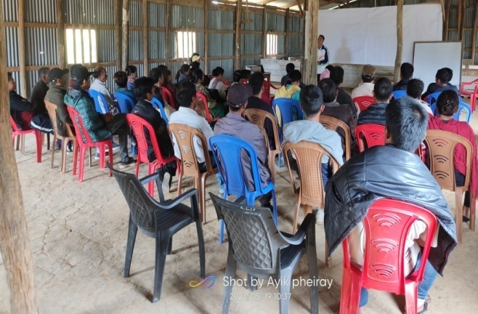
- Community Capacitation

PRA at LamyimPhungdhar ADCC Meeting at Ngahui

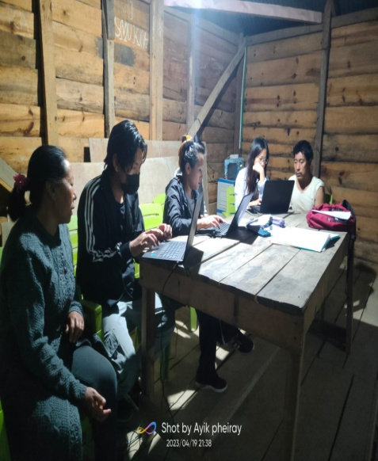
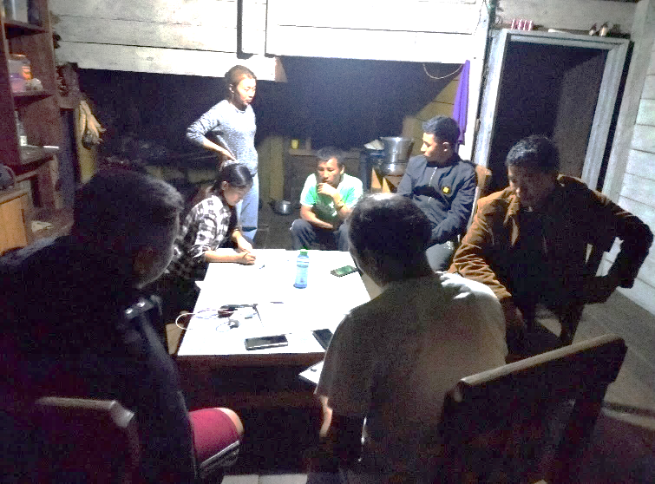
Village Profile collection at Loushing and Luireishimphung
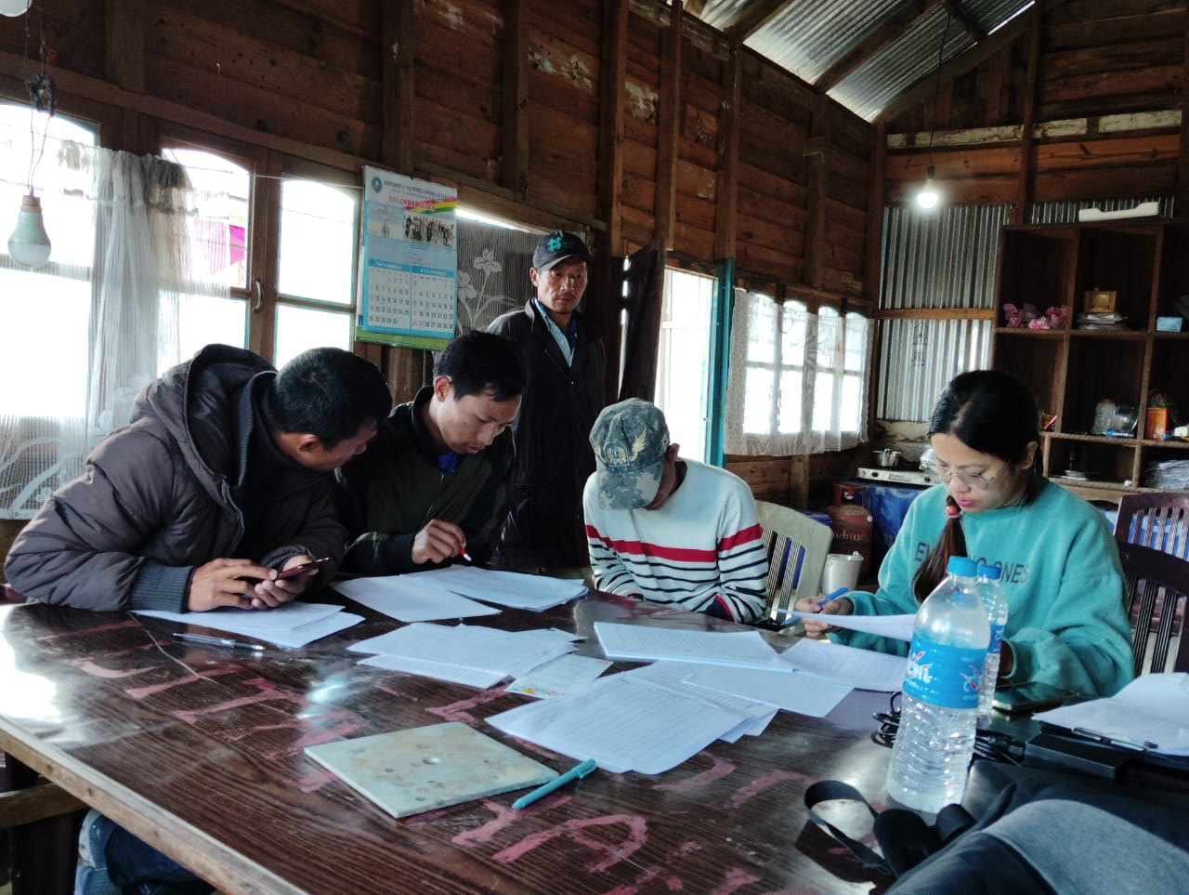
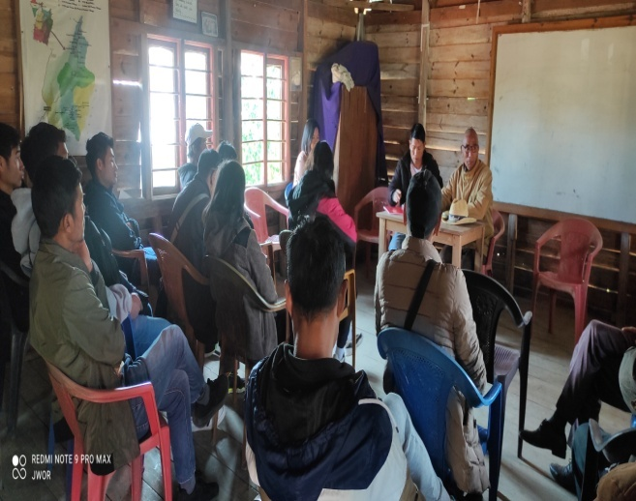
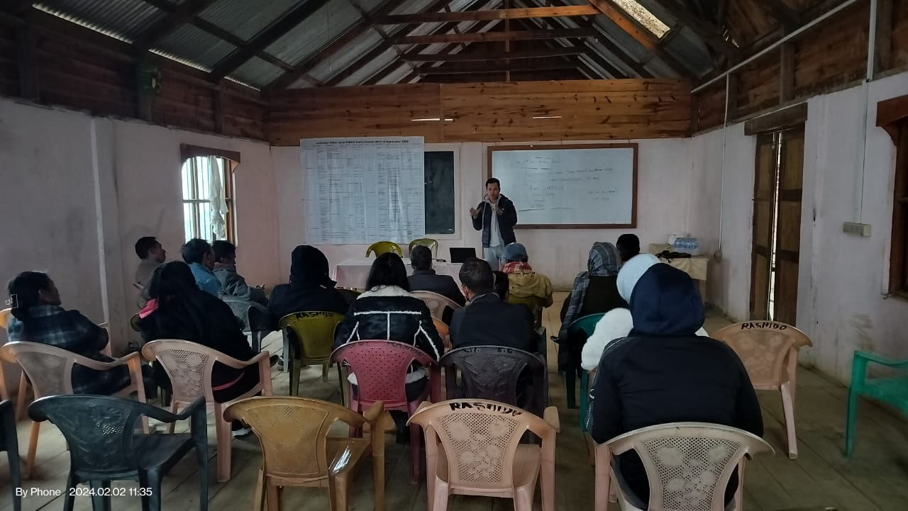
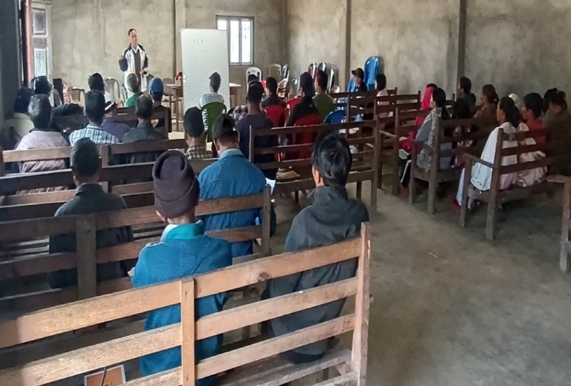
PRA exercise at Phungcham village Village Profile collection at Phungcham
ADCC meeting at RADIO ADCC meeting at LK ADIO

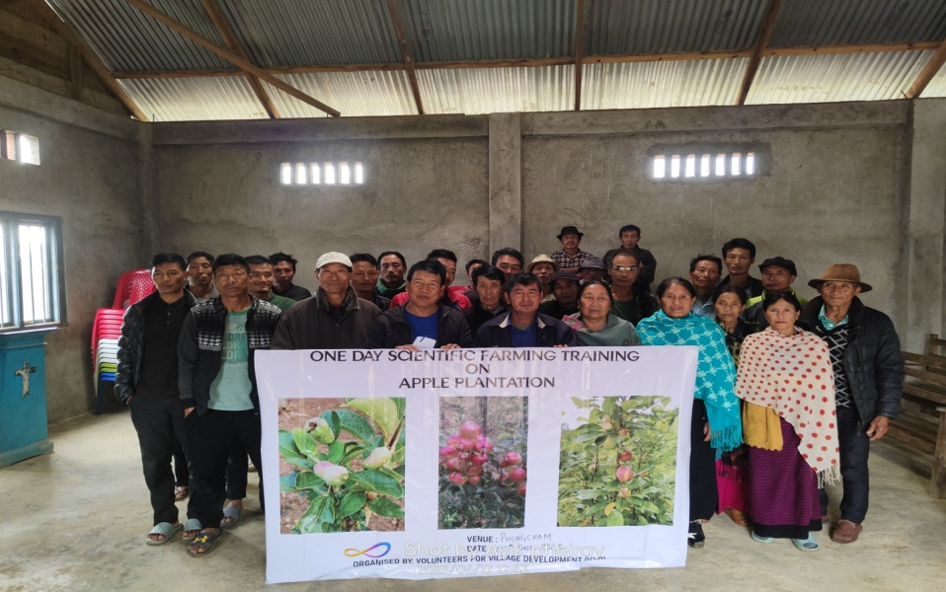
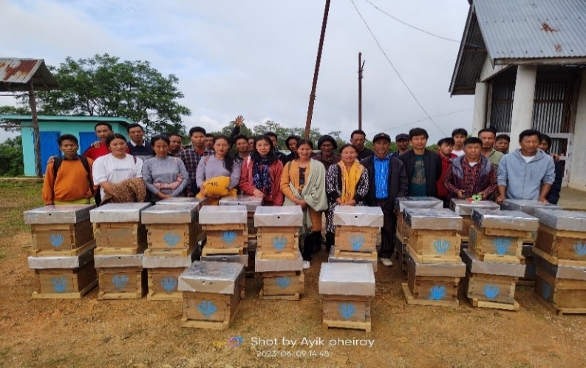
- Livelihood
Training on Bee Keeping at Khambi Training on Apple plantation at Peh

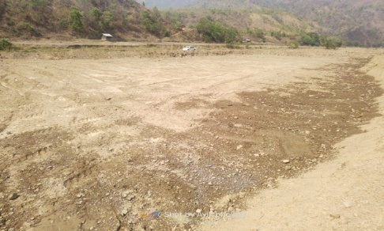
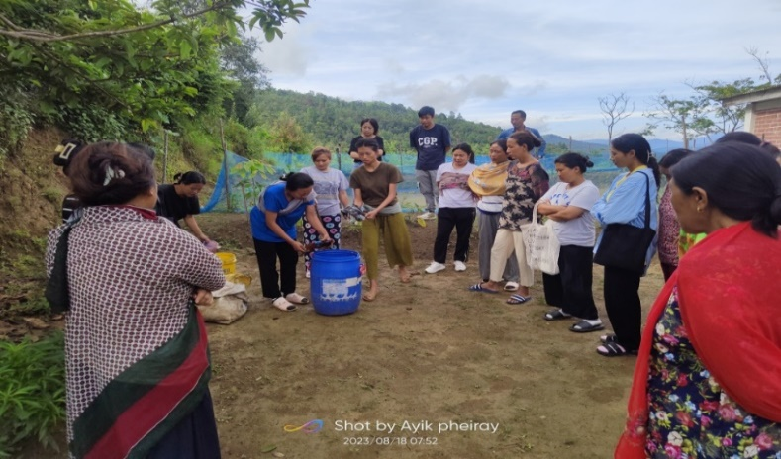
Training on Making Bio Fertilizer at Ngahui Land development at Peh
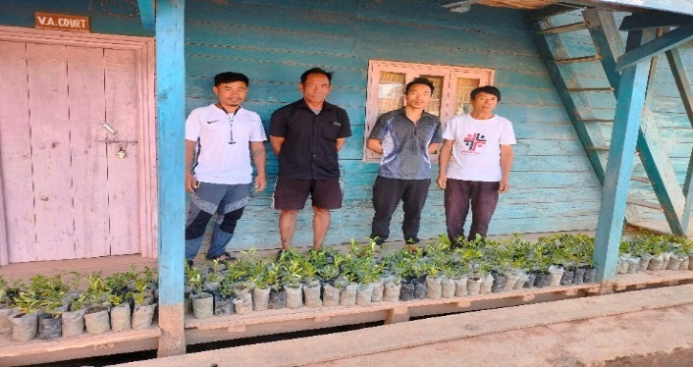
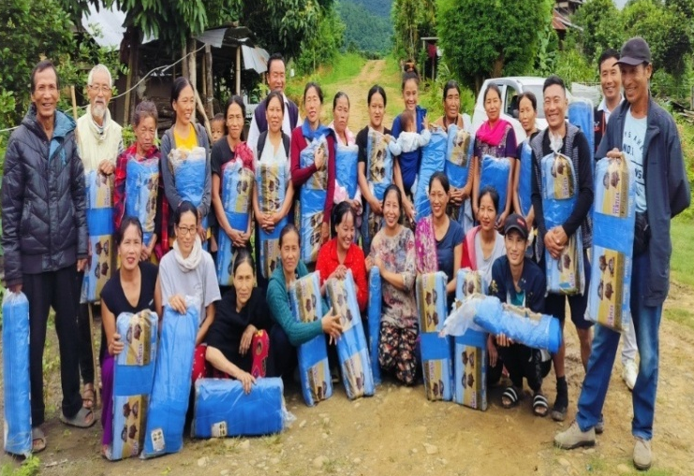

Kitchen garden net distribution at Changta Saplings distribution at Kumram

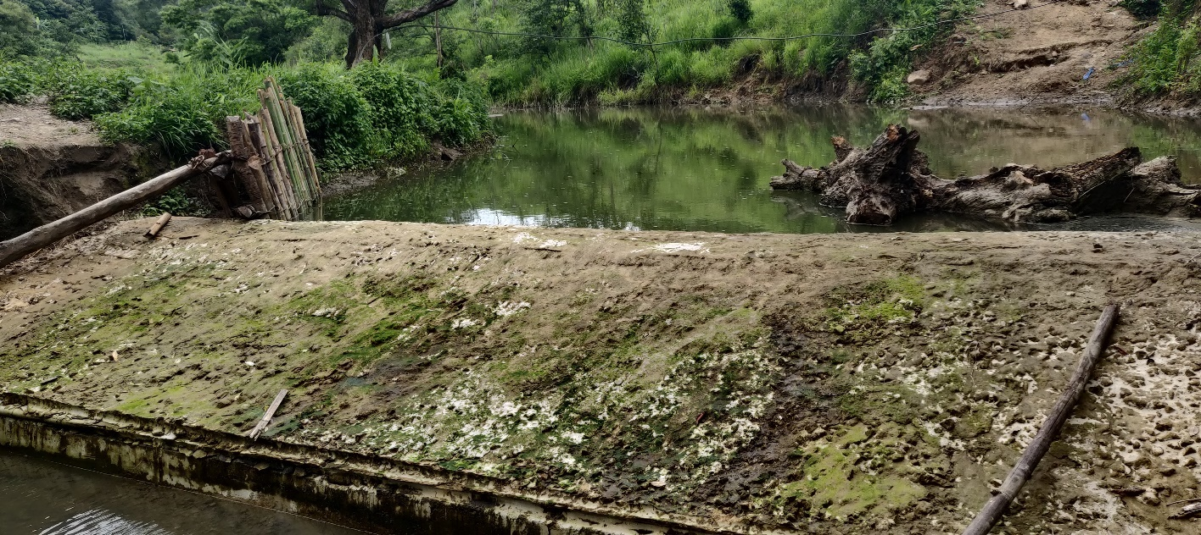
Check dam constructed at Changta village
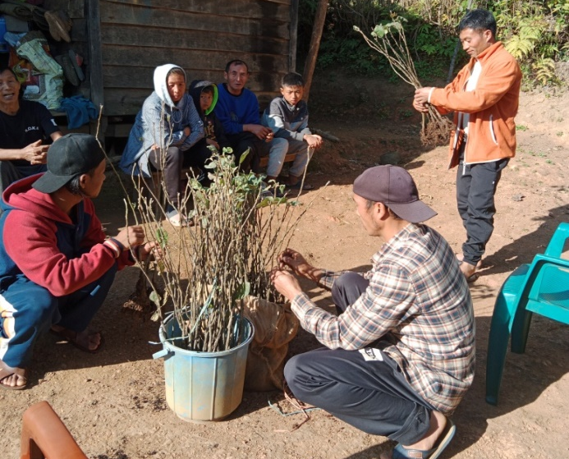
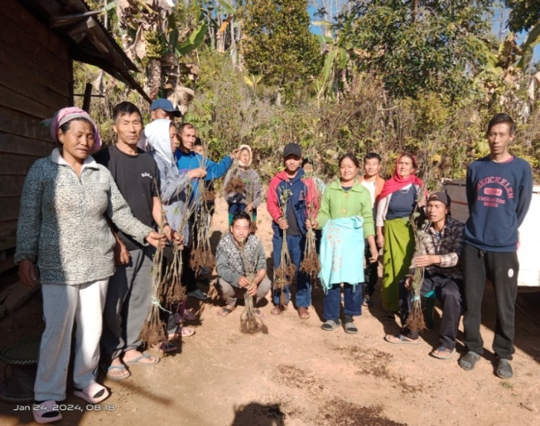
Fruit trees saplings distribution at Madoyah
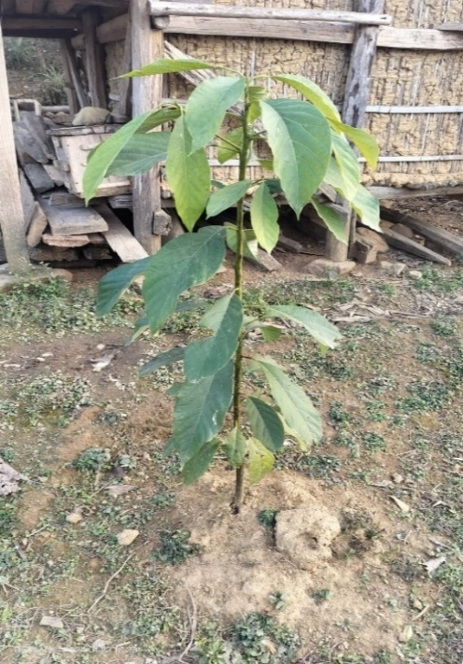
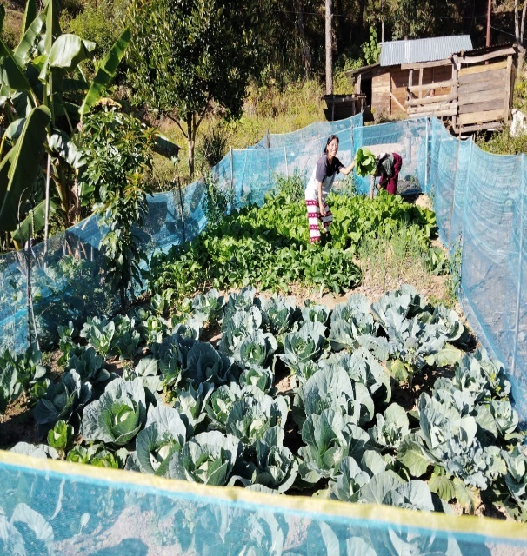

Kitchen garden at Chingjaroi CV Avocado sapling at Tanrui

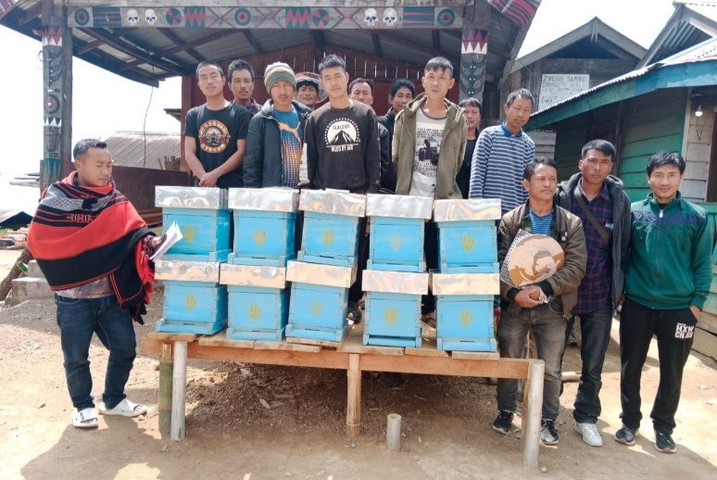
Bee Keeping Training & distribution of Bee boxes at Zingsui
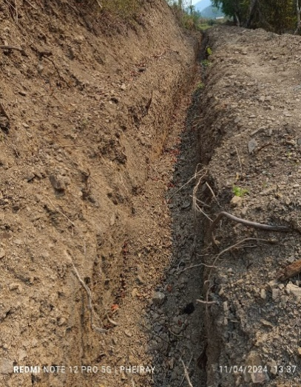
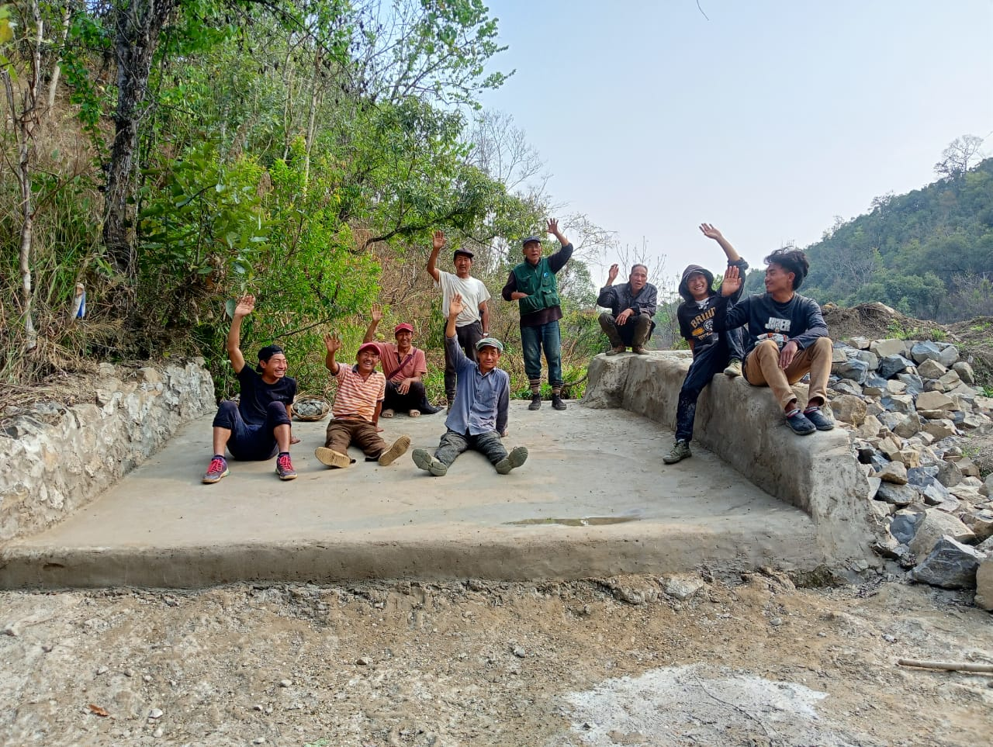
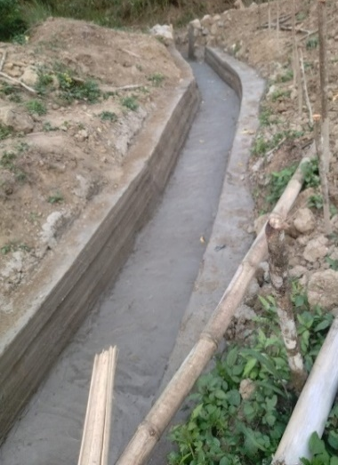
Minor irrigation at Tanrui Ramhon
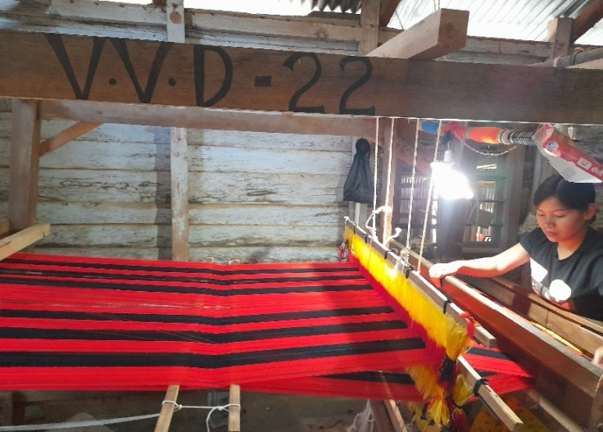
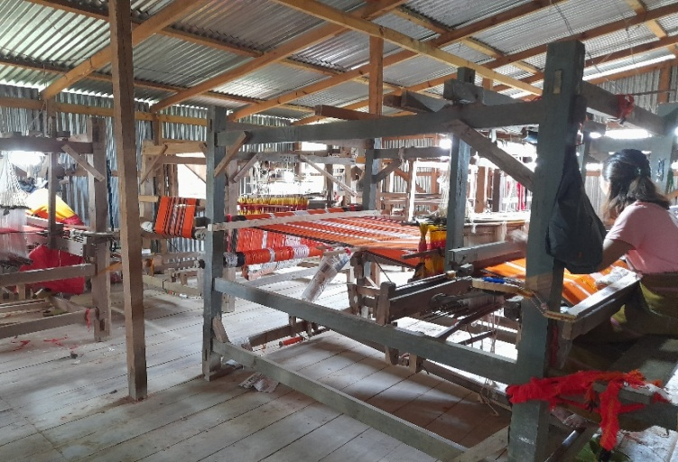
Training on weaving at VVD Training Centre

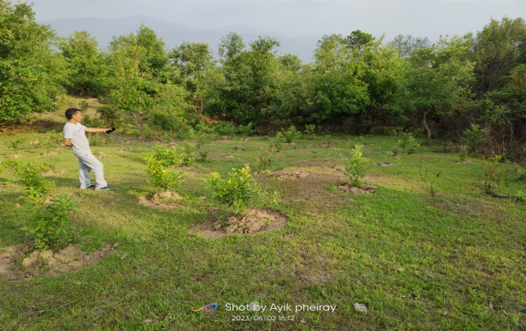
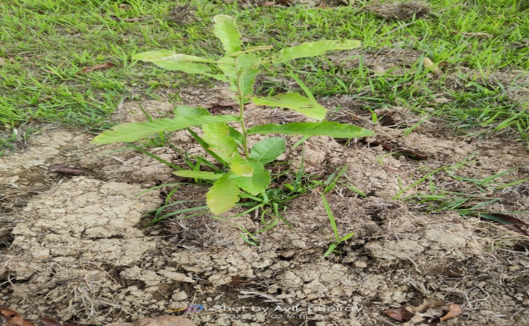
- Natural Resource Management
Monitoring of tree plantation at Phungcham

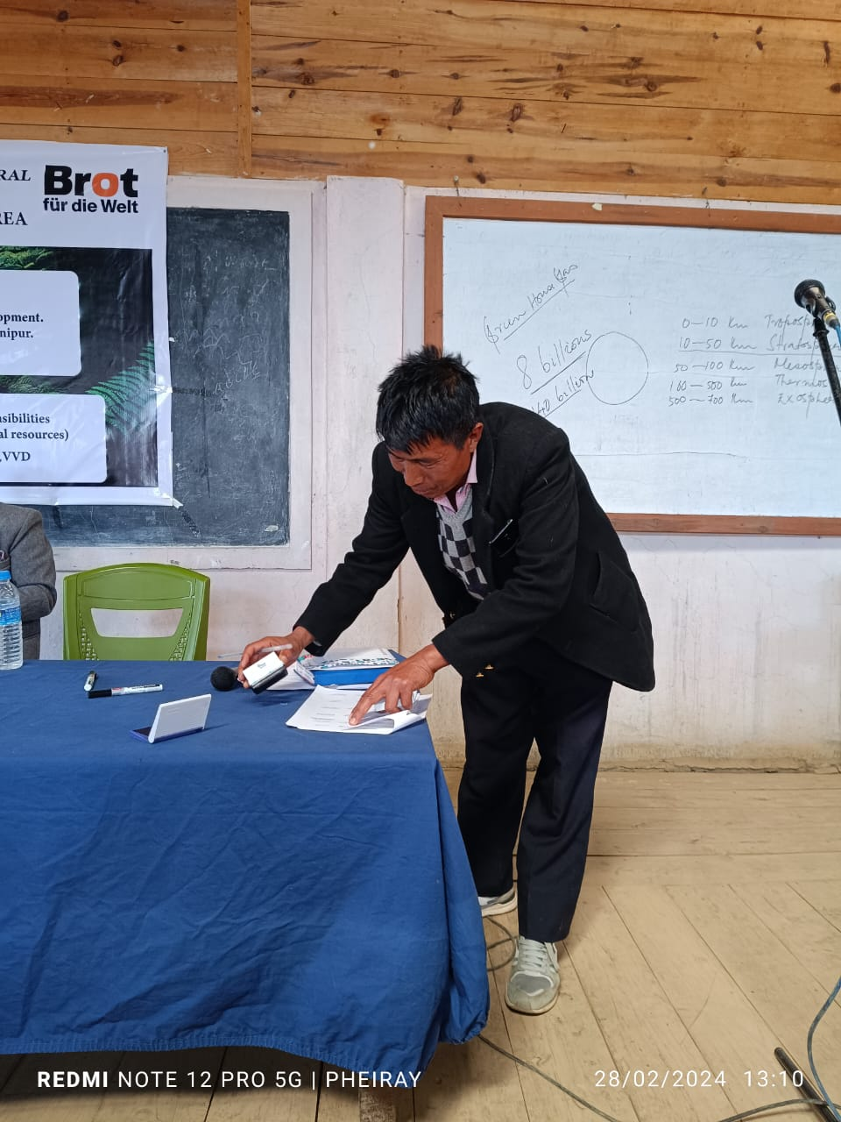
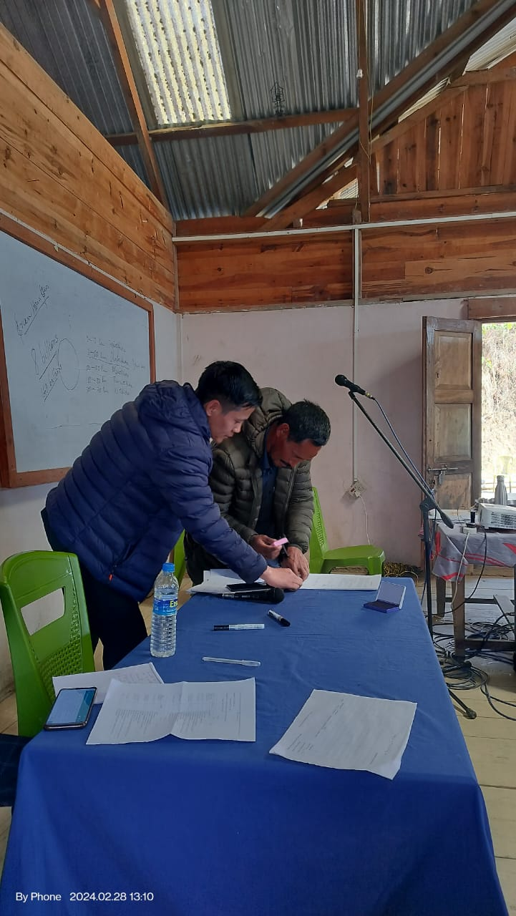

NRM Workshop &Sigining of MOU at Ngahui, RADIO

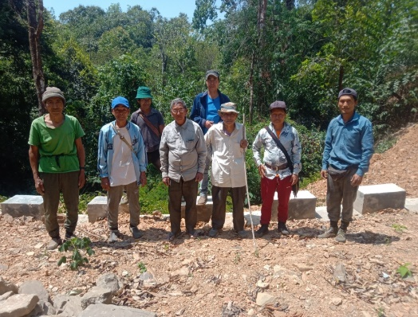
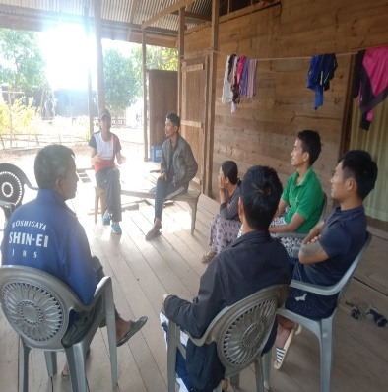
- Conflict Mitigation

GPS Mapping at between Patbung and Mailiang Meeting with VA at Punge on GPS

- Women Empowerment:
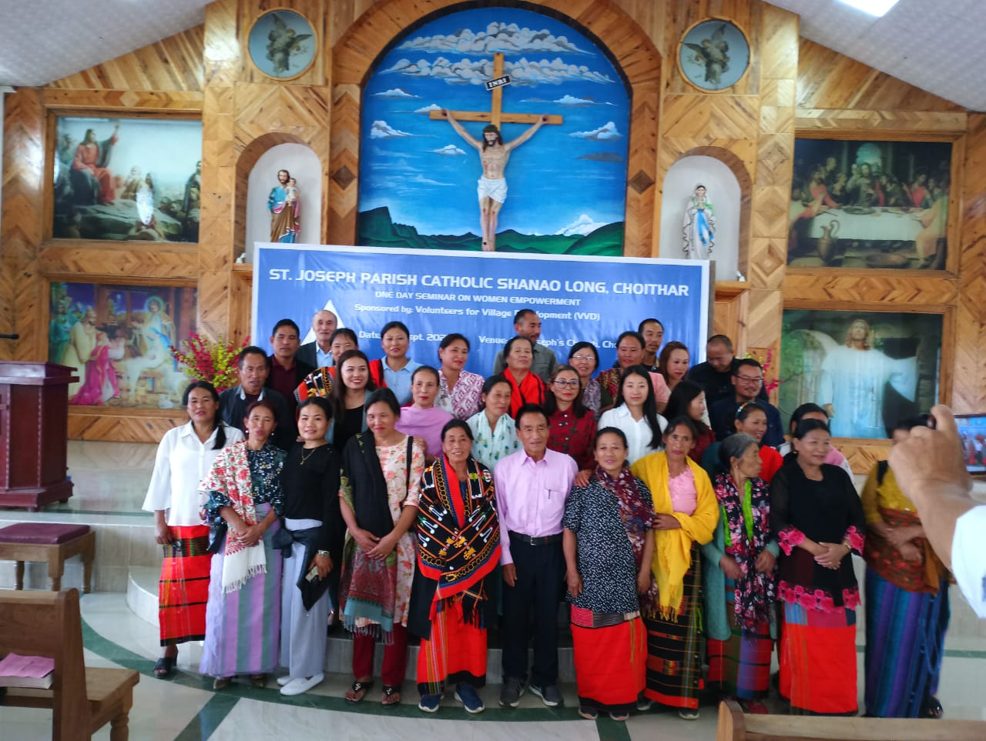

Workshop on Gender sensitization at Choithar

- Organizational Development
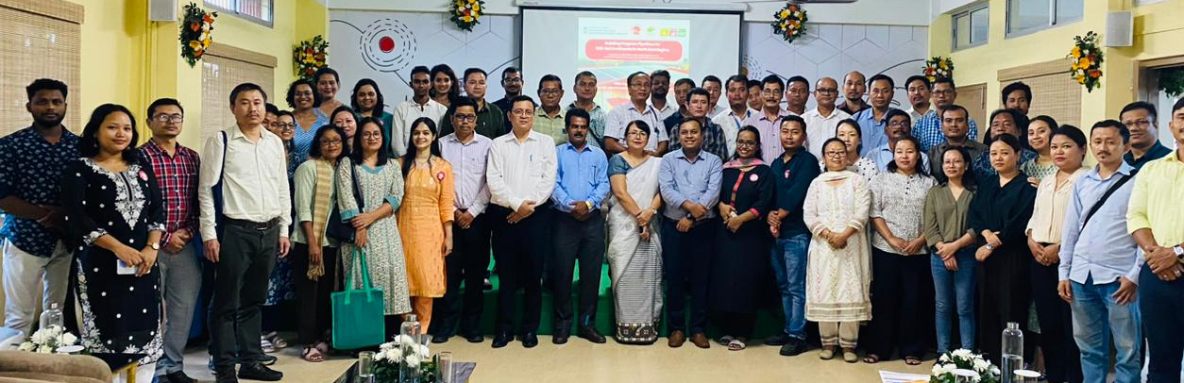
Workshop on “building program for pipelines for DRE for livelihood at Guwahati

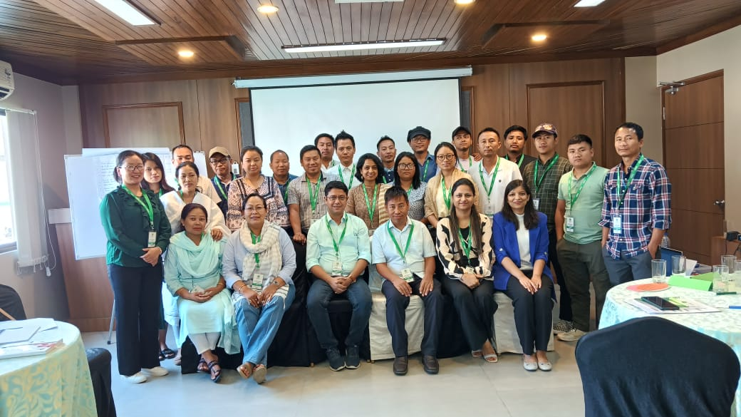

Workshop on Finance for Non-Finance at Imphal
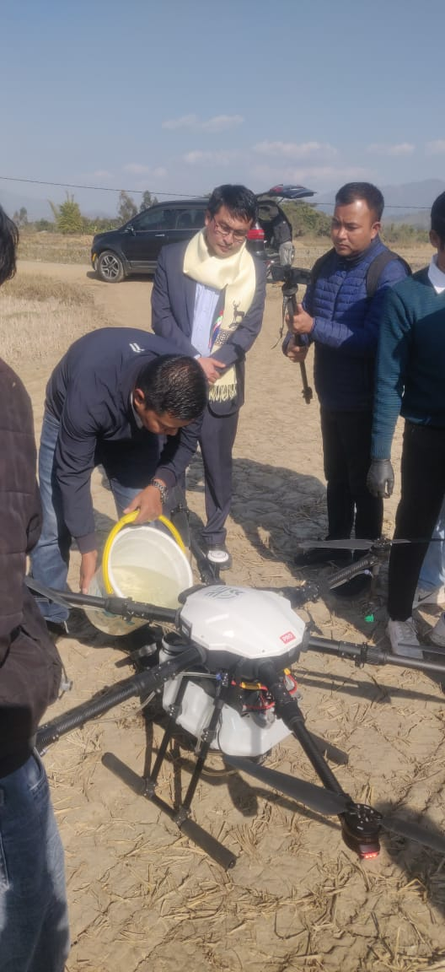
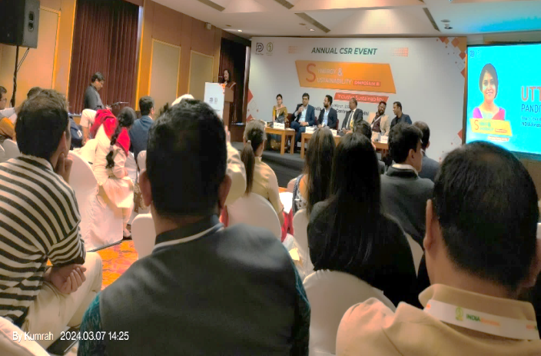
Training on drone application Participation at Annual CSR Event

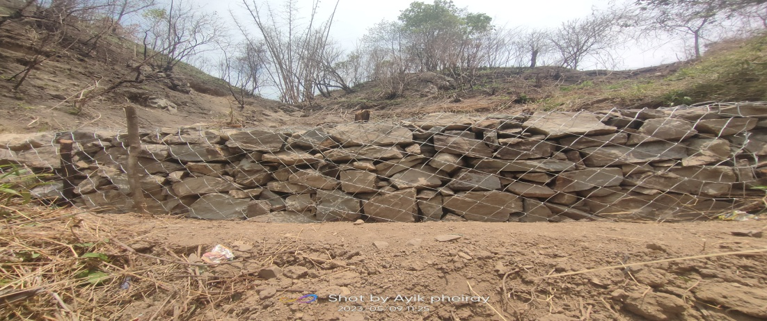
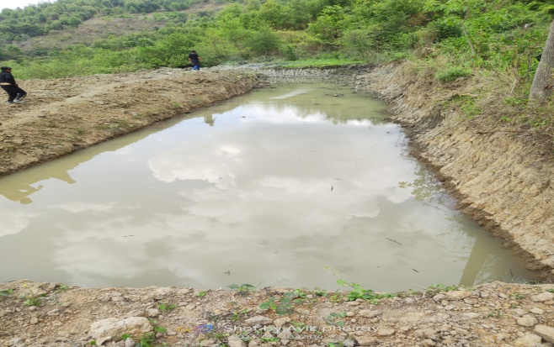
- Local Contribution Program

Dug out pond for Water conservation at Ngahui Gabion structure for water infiltration at Kalhang
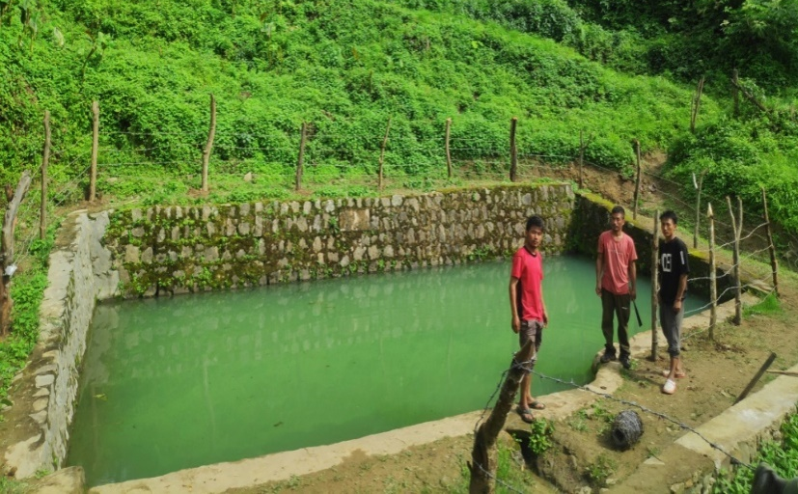
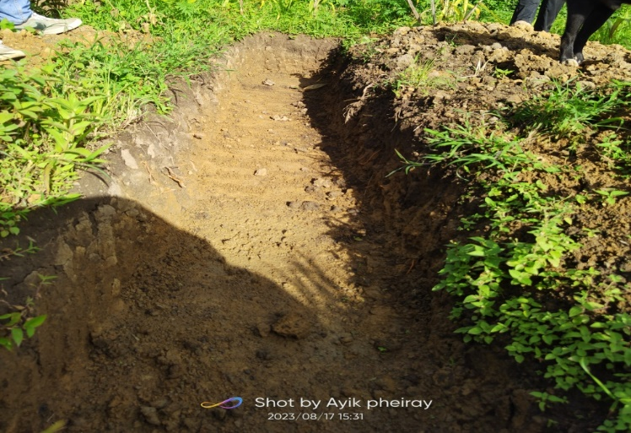
Staggered contour trenches at Kalhang Fencing for protection of Spring at Kalhang
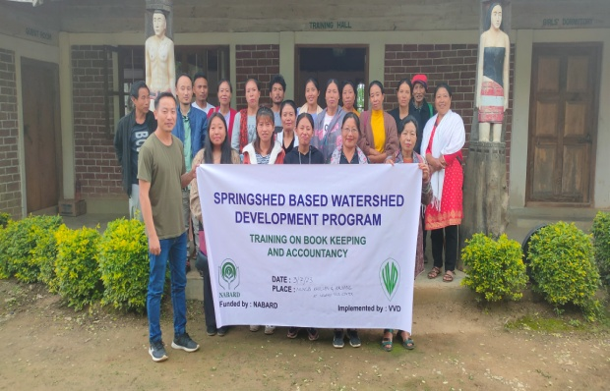
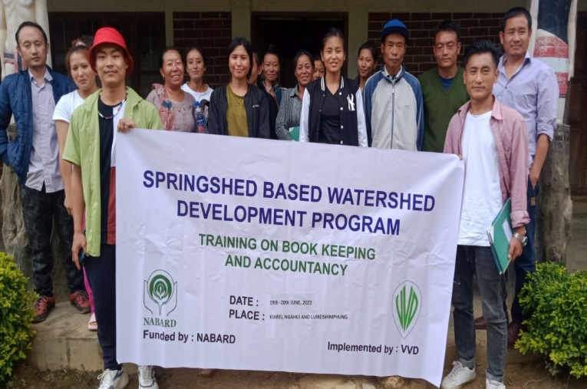
Cluster Wise Book keeping training at Ngahui

