

Volunteers For Village Development
Khaivaren Tang, Hungpung
Ukhrul District-795142, Manipur

Annual Report for the period April 2022 -March 2023

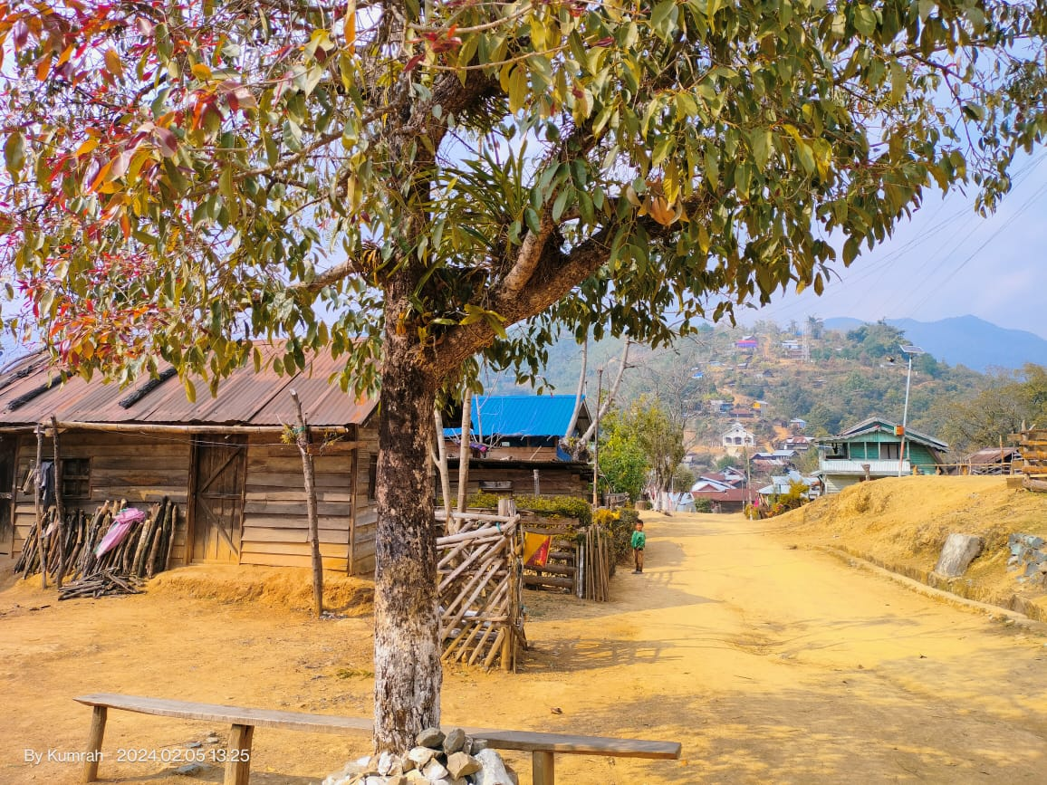

Sl. | Content | Page
1 | About the organization and Operational Area | 1
2 | Summary of the Program | 2
3 | Target and Achievement | 3
4 | Activities during the period | 3-7
5 | Challenges and Learning | 8
6 | List of Governing Body and Staffs | 11-12
7 | Activities Photographs | 13-17

Abbreviations:
ADCC- Area Development Coordination Committee
VDC- Village Development Committee
SHG- Self Help Group
L.K ADIO- Lungpha Khukhok Area Development Initiative Organization
RADIO- Raphei Area Development Initiative Organization
IIRDO- Ihang Iril Runrei Development Initiative Organization
SADIO- SAMBU Area Development Initiative Organization

The Volunteers for Village Development (VVD) is a Non-profit Organization working for Community Development. It was formed in 1982 by Retd. Capt. Ashok Y. Tipnis from Maharashtra together with Mr. Tennyson Kazingmei from Lunghar. The organization headquarter is based at Ukhrul.

Geographical Spread
In terms of hand holding support the project works with 42 villages while in terms of capacity building the project works across the district. The project has four field centers known as RADIO, L.K ADIO, IIRDO and SADIO.

Vision
We visualize a society with sustainable livelihood, where love brotherhood and equitable life prevails.

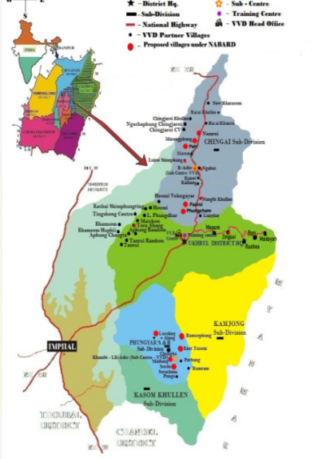
Mission
To enable self Help Initiatives of the people for sustainable livelihood, reducing conflict, liberating from discrimination and enhancing people’s participations in governance.

Operational Area at a Glance

1. | No. of Villages | 42
2. | No. of household | 5,819
3. | Population:
 | Male | 14,996
 | Female | 14,062
 | Total | 29,058

RADIO Villages | L.K ADIO Villages | IIRDO Villages | SADIO Villages
Lunghar  Nungbi Khullen  Kalhang  Kuirei  Ngahui  Luireishimphung  Phungcham  Namrei  Razai Khullen  Razai Khunou  Chingjaroi Khullen  ChingjaroiNgachaphung  Chingjaroi C.V  Kharasom C.V  New Kharasom  Peh | Alang  Loushing  Phungyar A  Phungyar B  East Tusom  Chungka  Khambi  Mailiang  Patbung  Kumrah  Shungri  Sorathen  Punge | Hoomi  Maichon  Aheng  Changta  Tanrui Ramhon  Tanrui  Ngainga  L.Phungdhar | Mapum  Zingsui  Rusheah  Roni  Madoyah

Summary of current Program Interventions
- Community Capacitation: Community in 42 villages have been organised at 3 levels- Self Help Groups at Group level, Village Development Committee at Village level and Area Development Coordination Committee (ADCC) at Area level. They are being capacitated in terms of awareness on issues related to social, economic, political (not party politics) and environment. They are also being capacitated in terms of skill to analyse local situation and plan relevant development programs. Through this intervention we have not only enabled the women Self Help Groups for economic gains but have also promoted women leadership at grass root. The involvement of women in the composition of Village Development Committee (VDC) has succeeded changing the Gender bias mindset at grass root level resulting to community accepting women’s participation in village assembly against tribal tradition in many villages. Representation in the VDC from all traditional institutions- church, youth, women and village authority has also helped promote transparency in village system. The formation of Area Development Coordination Committee has provided a platform to each of the four areas to deal with common issues.
- Livelihood: The first objective of program focuses on diversifying and increasing the source of families income for 1510 families in three years through fruit tree plantation, Bee keeping, Livestock keeping and other various income generating activities through trainings such as Cane and bamboo furniture making, bamboo handicrafts, weaving, food processing etc. Secondly, Enhancing food security of 1080 families by increasing the production and productivity of families through minor irrigation, land development and kitchen gardening and sustainable land use.
- Natural Resource Management:
The objective of the program focuses on rejuvenating of springs, survey and mapping of recharge area in 13 villages with 2390 household. Legislation on keeping of community forest conservation area, banning of poisoning rivers and use of electric devices for fishing and burning of forest, Banning on use of chemicals in farming, regulation on breeding season of birds and animals. Afforestation with local species are done annually in all the partner villages along with the legislation passed by the villages.
- Conflict Mitigation: The program has two objectives to resolve conflict without violence and to demarcate village boundary with GPS to avoid further inter village boundary conflicts. Here a target of 10 villages is kept for three years.
Program Target and Achievement (For Phase X, Oct. 2019-September 2022)
Sl. | Indicator | Overall target 3 years | Overall Achievement in 3 years | Annual Target | Annual Achievement
1 | By project end community in 42 partner villages are able to analyse local situations and plan relevant development programs. | 42 | 42 | 14 | 17
2 | By Project end improved socio-economic status of 2850 families in 42 partner villages will be visible through diversified sources of income. | 2850 | 5759 | 950 | 10
3 | By project end 2205 families have safe drinking water and reduce domestic energy consumption by 155 truckloads in a year. | 2205 | 1554 | 735 | 45

Program Target and Achievement (For Phase XI, Oct. 2022- Sept. 2025)
Sl. | Indicator | Overall target | Annual Target | Annual Achievement
1 | By project end community in 45 partner villages are able to analyse local situations and plan relevant development programs. | 45 | 15 | 18
2 | By Project end improved socio-economic status of 1510 families in 45 partner villages will be visible through diversified sources of income. | 1510 | 503 | 0
3 | By project end 45 villages have at least 4 regulative measures out of 6 in place to manage natural resource management | 45 | 15 | 7

Activity annexure for the period (April 2022-March 2023)
- Community Capacitation
Sl. | Activity | Villages | Date | Participants
 |  |  |  | M | F | Total
1 | 10th ADCC Meeting | Madoyah | 4th -5th April 22 | 7 | 8 | 15
1 | 10th ADCC Meeting | Hoomi | 28th April 22 | 6 | 7 | 13
1 | 10th ADCC Meeting | Khambi | 9th May 22 | 19 | 3 | 22
1 | 10th ADCC Meeting | Total |  | 32 | 18 | 50
1 | 11th ADCC Meeting | Mapum | 8th -9th July 2022 | 3 | 4 | 7
1 | 11th ADCC Meeting | Tanrui | 15th July 2022 | 11 | 6 | 17
1 | 11th ADCC Meeting | Khambi | 20th -21st July 2022 | 12 | 2 | 14
1 | 11th ADCC Meeting | RADIO | 11th July 2022 | 15 | 6 | 21
1 | 11th ADCC Meeting | Total |  | 41 | 18 | 59
1 | 12th ADCC Meeting | Roni | 23rd -24th Sept 2022 | 8 | 9 | 17
1 | 12th ADCC Meeting | Aheng | 27th Sept 2022 | 6 | 6 | 12
1 | 12th ADCC Meeting | Khambi | 28th Sept 2022 | 6 | 5 | 11
1 | 12th ADCC Meeting | RADIO | 27th Sept 2022 | 11 | 6 | 17
1 | 12th ADCC Meeting | Total |  | 31 | 26 | 57
1 | Phase XI – 1st ADCC Meeting | Madoyah | 16th - 17th Jan. 23 | 9 | 11 | 20
1 | Phase XI – 1st ADCC Meeting | Khambi | 29th-31st Jan. 23 | 14 | 9 | 23
1 | Phase XI – 1st ADCC Meeting | Ngahui | 21st Jan 2023 | 13 | 4 | 17
1 | Phase XI – 1st ADCC Meeting | Hoomi | 2nd Feb. 2023 | 6 | 2 | 8
2 | Preparation for external evaluation | Ngahui, Razai Khunou, Chingjaroi CV, Ngachaphung | 20th -23rd April 22 | 51 | 34 | 85
2 | Preparation for external evaluation | Maichon | 8th April 22 | 9 | 18 | 27
2 | Preparation for external evaluation | Ngahui | 8th April 22 | 4 | 47 | 51
2 | Preparation for external evaluation | Tanrui | 20th April 22 | 8 | 20 | 28
2 | Preparation for external evaluation | Zingsui and Roni | 22 - 23 April’22 | 28 | 7 | 35
2 | Preparation for external evaluation | Alang, Shungri, Mailiang,Punge | 8th -9th April 22 | 53 | 27 | 81
2 | Preparation for external evaluation | Total |  | 153 | 153 | 306
3 | Meeting with VDC,VA and beneficiaries of MI | Tanrui | 02nd May 22 | 13 | 3 | 16
4 | SHG Orientation | Tanrui, Changta | 14-15th May 2022 | 0 | 121 | 121
5 | Training on Pig Rearing and formation of SHG | New Kharasom | 21st -22nd July 2022 | 10 | 4 | 14

Sl. | Activity | Villages | Date | Participants
 |  |  |  | M | F | Total
6 | Promotion of Indigenous fish at Iril river | Aheng | 22nd July 2022 | - | - | 8 villages
7 | Training on Lemon crafting and air layering | Kachai | 27th July 2022 | 21 | 2 | 23
8 | Baseline collection and monitoring of project activities | 5 villages of SADIO  11 villages of LK ADIO  RADIO partner villages  IIRDO partner villages | 24th -28th Oct.22  25th -29th Oct.22  17th – 24th Nov.22  15th – 18th Nov.22 | 46  113  138  39 | 23  69  44  35 | 69  182  182  74
9 | Program Concept Orientation – Phase-XI | 11 villages of LK ADIO  5 villages of SADIO  19 villages of RADIO  and IIRDO | 13th -17th Feb.23  17th -20th Feb.23  16th-22nd Jan.23 | 151  84  111 | 64  37  44 | 215  121  155
10 | Orientation of VDC on their Role and Responsibilities | LK ADIO villages  SADIO villages | 20th-24th Mar.23  16th -18th Mar.23 | 93  31 | 43  14 | 136  45

2.Livelihood
Sl. no. | Activity | Villages | Date | Families covered
1 | Land development | Sorathen | August 2022 | 10
2 | Monitoring of Piggery | New Kharasom | 18th -19th Aug 2022 | 13
3 | Transportation of 224 Fruit saplings (Pomegranate, Jackfruit and Avocado) | Ngahui | 1st -2nd Sept 2022 | 1
4 | Seeds and saplings distribution | Alang, Loushing, Phungyar,  Chungka, East Tusom,  Khambi, Patbung, Kumram,  Maileng, Sorathen, | 13th-17th Feb, | 308
4 | Seeds and saplings distribution | Mapum, Rusheah, Roni. | 28th March’23 | 69
4 | Seeds and saplings distribution | Hoomi, Maichon, A.Changta, New Kharasom, Chingjaroi C.V, Razai Khunou, Nungbi, Razai Khullen, Lunghar | 6th Feb,  20th -22nd March’23 | 405
5 | Land Development and Minor Irrigation | Madoyah | Jan-March 23 | 14
5 | Land Development and Minor Irrigation | Roni | Jan-March23 | 31
5 | Land Development and Minor Irrigation | Razai Khunou | Jan-March23 | 68
5 | Land Development and Minor Irrigation | Naghui | Jan-March23 | 6
5 | Land Development and Minor Irrigation | Chingjaroi Khullen | Jan-March | 8
5 | Land Development and Minor Irrigation | Hoomi | Feb-March | 11
6 | Training on Fruit trees, Pests and diseases Management | Kumram | 25th March23 | 45
6 | Training on Fruit trees, Pests and diseases Management | Tanrui, Hoomi | 11th -12th March 2023 | 99
7 | One day Scientific Training on Apple Farming | Lunghar | 6th Feb.2023 | 15
8 | Community Farm Fencing | Zingsui | Feb-March 2023 | 52

2.2. List of weaving trainees
Name of trainees
Thotrani Shimray | Rinsemmi Vasha | Rinyami Khamrang | Rinthingla Zimik | Kh. Soreichon
Ramyaola Shimray | Yarmichon Longpinao | SoshanVashum | J. Mayorin | Chanthing
Shila Kotwal | Thawonla | Yarmila | Shangreiphy | Angel
Wungshungmi | Wontimla | Lanmi | Ngathingchon

3. Natural Resource Management
Sl.no | Activity | Villages | Date | No. of H/H covered
1 | Monitored Chulha Construction for 5 beneficiaries | Razai Khunou | 2nd –June 2022 | 5
2 | Construction of Chulha | Mapum | 28th -30th June’22 | 45
3 | Sapling distribution for Community tree Plantation | Nungbi, Kuirei, Ngahui, Lshimphung, Chingjaroi CV, Ngachaphung, C Khullen | 22nd June 2022 | Community
3 | Sapling distribution for Community tree Plantation | Changta | July 2022 | Community  (500 Uningthou )
3 | Sapling distribution for Community tree Plantation | 13 villages | Feb-April’23 | 70,620 seeds and saplings
4 | Workshop on Natural Resource management and awareness on land compensation | Khambi | 9th -11th March 2023 | 57

 | - Conflict Mitigation
Sl. | Activity | Villages |  | Date |  | Participants
 |  |  |  |  |  | Male |  | Female |  | Total
1 | Village Boundary mapping | Punge with Nongman, Nongman with Kumram, Patbung |  | 9th -15th Jan,  6th -12th Feb,  3rd -6th, 9th-12th March’23 |  | 17 |  | 0 |  | 17
2 | Signing of No Objection Certificate with Neighbouring villages | Punge |  | 28th-29th March 2023 |  | 32 |  | 7 |  | 39
3 | Meeting for Conflict mitigation | Chingjaroi and  Kharasom |  | January 24, 2023 |  | 3
- Women Empowerment
Sl. | Activity |  | Place | Date | Participants
 |  |  |  |  | Male |  | Female |  | Total
1 | Celebration of international Women’s Day in collaboration with Tangkhul Shanaolong, and PASDO |  | Ukhrul | 9th March 2023 | 38 |  | 116 |  | 154
2 | Zonal workshop of Village Chief and Village Authority members on Tangkhul Customary laws |  | Ukhrul | 17th March 2023 | 81 |  | 0 |  | 81

6. Cane and Bamboo Training Cum Production under NECBTC
Sl. No | Activity | Place | Date | Participants
 |  |  |  | Male | Female | Total
1 | Training on Cane and bamboo Furniture and Handicraft | Cane and Bamboo training cum production centre (VVD) | 30th June-29th July | 14 | 1 | 15
2 | Training on Cane and bamboo Furniture and Handicraft | Cane and Bamboo training cum production centre (VVD) | 28th Sept – 28th Oct. | 15 | 1 | 16
3 | Guru Shishya Hastshilp Prashikshan training program on Bamboo utility handicrafts assembler- cane and bamboo | Cane and Bamboo training cum production centre (VVD, Campus) | 16th Nov. 2022-13th Jan. 2023 | 21 | 4 | 25
4 | Training on Cane and Bamboo handicrafts making | Cane and Bamboo training cum production centre (VVD, Campus) | 14th Feb. to 12th March 2023 | 12 | 2 | 14

Program B: Springshed based Watershed Development program
The objective of the program is to rejuvenate drying springs in 10 villages with acute water shortage by identifying the recharge area of springs in the villages. The following activities are taken up under the program.
- Treatment Measures
The main objective of this activity is to infiltrate and recharge the springs. At the recharge area the activities like digging of staggered contour trenches, percolation, and brushwood dams were dug and constructed. For soil and water conservation saplings of indigenous species and fruit trees are planted, contour terrace land were constructed for food security of farmers. Fencing for recharge area protection was constructed.

- Livelihood program
Piggery project was taken up through 4 different SHGs. We convert grant mechanism in a revolving strategy where the supported members will repay the seed money after 6 months. A total of 49 individuals were covered during the period.

- Capacitation
Communities were again oriented on the concept of springshed development. Community were made aware of the various impact of using fertilizers, pesticides and weedicides on soil, water and health by giving them training on natural farming.

Programs implemented under NABARD (April 2022 – March 2023)
Sl. | Activities | Participants |  | Total | Date | Villages
Sl. | Activities | M | F | Total | Date | Villages
1 | Meeting with SHGs on piggery project | 0 | 134 | 134 | 7th -8th April 22 | Nungbi, Kuirei, Ngahui
2 | Training and field visit | 3 | 1 | 4 | 10th -12th April 22 | Imphal ,Lunghar
3 | Field visit with Indian Institute of Horticulture Research Bangalore on Avocado survey | 20 | 32 | 52 | 20th April 22 | Nungbi, Ngahui
4 | Field visit with NABARD | 40 | 30 | 70 | 20th April 22 | Kalhang, Nungbi
5 | Review meeting at NABARD, RO, Imphal | - | 1 | 1 | 27th April 22 | Imphal Nabard office
5 | Review meeting at NABARD, RO, Imphal | 2 | 0 | 2 | 10th Feb.23 | Imphal Nabard office
6 | Program Monitoring | 3 | - | 3 | 6th -7th May 22 | Kalhang
7 | Field visit with UDWIM and NABARD | 1 | 0 | 1 | 10th May 22 | Kachai
8 | SHG livelihood project | 0 | 15 | 15 | 1st May 22 | Kuirei
8 | SHG livelihood project | 0 | 19 | 19 | 8th May 22 | Ngahui
8 | SHG livelihood project | 0 | 7 | 7 | 25th April 22 | Luireishimphung
8 | SHG livelihood project | 0 | 8 | 8 | 22nd May 22 | Nungbi
9 | Percolation and dugout Pond | 2 | - | 2 | 2nd, 5th April 22 | Kuirei
9 | Percolation and dugout Pond | 4 | - | 4 | 11th -12th April 22 | Ngahui
9 | Percolation and dugout Pond | 1 | - | 1 | 13th April 22 | Luireishimphung
9 | Percolation and dugout Pond | 10 | - | 10 | 29th -31st March 22 | Nungbi
10 | Bench Terrace | 5 | 1 | 6 | 29th -31st March 22 | Nungbi
11 | Training on Natural Farming | 9 | 33 | 42 | 18th -19th May 22 | Luireishimphung
11 | Workshop on Natural Farming | 49 | 13 | 62 | 5th , 14th August’22 | Ngahui, Nungbi
12 | Contour line measurement and monitoring of projects | 7 | 0 | 7 | 18th -19th May 22 | Luireishimphung, Kuirei, Kalhang
13 | Geo tagging of activities | 2 | 0 | 2 | 18th -19th May 22 | Nungbi
13 | Geo tagging of activities | 16 | 3 | 19 | 7th-11th Nov.22 | Nungbi, Kuirei, Kalhang, Lshimphung, Ngahui
14 | Barbed wire fencing support | 7 | 0 | 7 | 4th June 22 | Kuirei, Nungbi
14 | Barbed wire fencing support | 7 | 0 | 7 | 14th July 2022 | Nungbi
15 | Lemon sapling distribution  800 Nos. | 12 | 12 | 24 | 7th June 22 | Luireishimphung
15 | 174 Nos. | 3 | 0 | 3 | 19th April22 | Kuirei
15 | 526 Nos. | 81 | 19 | 100 | 11th July 2022 | Ngahui
15 | Sapling distribution | 7 | 0 | 7 | 5th July 2022 | Nungbi
15 | Sapling distribution | 9 | 0 | 9 | 28th July 2022 | Nungbi
16 | Tree plantation | 25 | 18 | 43 | 24th June 22 | Ngahui
16 | 930 nos. | 16 | 6 | 22 | 13th June 22 | Nungbi
16 | Tree Plantation | 21 | 0 | 21 | 5th July 2022 | Nungbi
17 | Digging Contour Trenches  437 pits | 50 | 13 | 63 | 25th June 22 | Ngahui
 | 304 nos | 20 | 0 | 20 | 13th -14th April 22 | Kuirei
 | 1312 nos. | 20 | 14 | 34 | 24th -31st May 22 | Luireishimphung
 | 1012 nos. | 7 | 80 | 87 | July 22 | Nungbi
18 | Field visit with NABARD and MSCB staff | 5 | 30 | 35 | 7th July 2022 | Kalhang, Nungbi
19 | Collection of baseline survey | - | - | 119 | 18th 20th July 2022 | Paorei, Maichon and Aheng

Sl. | Activities | Participants |  | Total | Date | Villages
Sl. | Activities | M | F | Total | Date | Villages
20 | Construction of brushwood Dam | 31 | 7 | 38 | 12th -14th July 2022 | Kuirei
20 | Construction of 3 brushwood dam | 80 | 0 | 80 | July 2022 | Nungbi
21 | Protection of recharge area by fencing | 3 | 0 | 3 | 4th -12th July 2022 | Kuirei
22 | Monitoring and survey | 14 | 2 | 16 | 5th -8th July 2022 | Ngahui, Kuirei, Kalhang, Nungbi
23 | Kitchen Garden net for crop protection | 0 | 33 | 33 | 14th July 2022 | Luireishimphung
24 | Monitoring of contour trenches | 7 | 1 | 8 | 27th July 2022 | Nungbi
25 | Program Monitoring and verification for phase II activities | 4 | 1 | 7 | 7th -8th Sept 2022 | Nungbi
26 | Meeting with Village leaders on PPIP | 9 | 6 | 15 | 25th Sept 2022 | Kachai
27 | DPR preparation survey | 20 | 0 | 20 | 9th -11th August’22 | Paorei, Maichon, Aheng
26 | PRA | 23 | 31 | 54 | 8th -10th Oct.22 | Kachai
29 | Accountancy Training | 11 | 24 | 35 | 10th-11th Oct.22 | Kachai
30 | Construction of Rest House under EPA | Community |  |  | Oct-Dec | Kachai
31 | Monitoring of contour trenches | 4 | 2 | 6 | 22nd Nov.22 | Kuirei
32 | Exposure visit by WAGGS | 15 | 9 | 24 | 17th Feb. 23 | Kalhang
33 | Phase II project Orientation and meeting with beneficiaries | 23 | 19 | 42 | 29th March 23 | Kalhang and Nungbi

Organisational Development:
Sl. | Activity | Place | Date | Participants
1 | External Evaluation | Tanrui, Maichon, | 8th May’22 | 67
1 | External Evaluation | Chingjaroi Ngachaphung, Chingjaroi C.V, Ngahui, Razai Khunou, Kalhang | 6th -7th May’22 | 148
1 | External Evaluation | Roni, Zingsui | 8th May’22 | 28
1 | External Evaluation | Alang, Shungri, Punge | 9th May’22 | 90
2 | Certificate course in Financial Management and Accountability | Online | 2nd May-30th June | 2
3 | Workshop on Do No Harm | Online | 23rd -25th August’22 | 4
4 | Meeting with Azim Premji Foundation | Imphal | 19th July 2022 | 1
4 | Meeting with Azim Premji Foundation | RADIO, Ngahui | 14th -15th Nov’22 | 62
5 | Training on springshed management and Field visit | Imphal | 10th -12th April’22 | 2
5 | Training on springshed management and Field visit | Kohima | 12th -15th Dec 2022 | 2
5 | Regional Meeting on Springshed | Imphal | 10th Feb’23 | 1
6 | Project Management Professional (PMP) | Online | October-November | 1
7 | Meeting on SHGs and its activities organised by NABARD in collaboration with MSRLM | Ukhrul | 15th November 2022 | 2
8 | Training on Apple Plantation | VVD office, Ukhrul | 23rd Jan 2023 | 18
9 | Workshop on Compliance and Accountability (FMSF) | Delhi | 1st – 4th March 2023 | 2

Non Monitory participation
Sl. No. | Activities | Village | Month | Specification
1 | Community Tree Plantation | Chingjaroi CV | June 2022 | Dalhao, cherry, Evergreen
1 | Community Tree Plantation | Lunghar | June 2022 | Oak and other local species
1 | Community Tree Plantation | Namrei | June 2022 | Cherry,
1 | Community Tree Plantation | Chungka | May-June 2022 | Wild olive, Taphekra, Leiho
1 | Community Tree Plantation | Namrei | April 2022 | Oak
1 | Community Tree Plantation | Kalhang | April 2022 | Oak
1 | Community Tree Plantation | Maichon | May 2022 | Pine and other local species
1 | Community Tree Plantation | Punge | July 2022 | Cherry
1 | Community Tree Plantation | Khambi | May 2022 | Perkia, lemon
1 | Community Tree Plantation | Mailiang | May 2022 | Perkia, Lemon
1 | Community Tree Plantation | Nungbi | February 2023 | Oak and Alnus
1 | Community Tree Plantation | Kuirei | November 2023 | Oak, Perkia and Other local species
1 | Community Tree Plantation | Tanrui Ramhon | March 2023 | Oak, Perkia and other local species
1 | Community Tree Plantation | A.Changta | March 2023 | Ginger
2 | Cleanliness Drive | Chingjaroi CV | May, August 2022 | Village Compound
2 | Cleanliness Drive | Hoomi | Feb 2023 | Drainage, and surroundings, constructing dustbins
2 | Cleanliness Drive | Tanrui | Every 1st Saturday | Drainage, and surroundings, constructing dustbins
2 | Cleanliness Drive | Razai Khunou | Feb, 2023 | Drainage, and surroundings, constructing dustbins
2 | Cleanliness Drive | Ngahui | Feb, 2023 | Drainage, and surroundings, constructing dustbins
2 | Cleanliness Drive | Namrei | March 2023 | Drainage, and surroundings, constructing dustbins
2 | Cleanliness Drive | Ngahui | October 2022 | Drainage, and surroundings, constructing dustbins
2 | Cleanliness Drive | Razai khullen | October 2022 | Drainage, and surroundings, constructing dustbins
2 | Cleanliness Drive | Kharasom CC | December 2022 | Drainage, and surroundings, constructing dustbins
3 | Road Repairing and Clearance | Namrei | July 2022 | Repairing of 4 km paddy road
3 | Road Repairing and Clearance | Namrei | October 2022 | Repairing of 4 km paddy road
3 | Road Repairing and Clearance | Nungbi | November 2022 | Repairing done within the village
3 | Road Repairing and Clearance | Ngahui | October 2022 | Repairing done from market area to local area
3 | Road Repairing and Clearance | Hoomi | Sept 2022 | Repairing of 6 km paddy road
3 | Road Repairing and Clearance | Hoomi | October 2022, | Repairing of 6 km paddy road
3 | Road Repairing and Clearance | Hoomi | January 2023 | Repairing of 6 km paddy road
3 | Road Repairing and Clearance | Tanrui | October and November 2022 | Repairing of paddy road
3 | Road Repairing and Clearance | Razai Khullen | October 2022 | Repairing of 6 km paddy road
3 | Road Repairing and Clearance | Maichon | Sept 2022 | Repairing of 9 km paddy road
4 | Construction of Waste Bin | Chingjaroi CV | June 2022 | 80 Nos.
4 | Construction of Waste Bin | Namrei | April 2022 | 30 Nos.
5 | Construction of Mini water Tank | Chingjaroi CV | June 2022 | 1 unit
6 | Installation of Transformer | Kumram | 2022 | 1 No. of Transformer
7 | Repairing of pipeline  Construction of farm pond | Hoomi | January 2023 | 6 km
7 | Repairing of pipeline  Construction of farm pond | Tanrui | March 2023 | New alignment approx 5Km
7 | Repairing of pipeline  Construction of farm pond | Kharasom CC | February 2023 | 1 km, replacement of new pipeline
7 | Repairing of pipeline  Construction of farm pond | A. Changta | March 2023 | 1 Fishery Pond
8 | Construction of Rest House | A. Changta | March 2023 | 2 Rest Shed at Eco- Park
9 | Crowd funding and Installation of solar lights at the village Compound | Sorathen | March 2023 | 3 Solar Lights

 | Program taken up under Never Alone Home
Sl. | Activity | Place | Date | Participants
 |  |  |  | Male | Female | Total
1 | School fees | Ukhrul | Oct 22 -March 23 | 13 | 3 | 16
2 | Food and lodging | Ukhrul | Oct 22 -March 23 | 13 | 3 | 16
3 | Uniforms and Books | Ukhrul | Jan 2023 | 11 | 2 | 13

Photographs program Activities for the period April 2022-March 2023
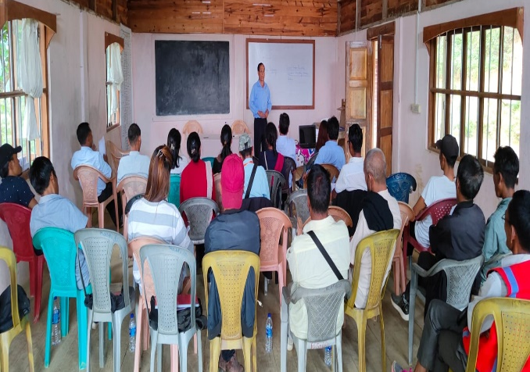
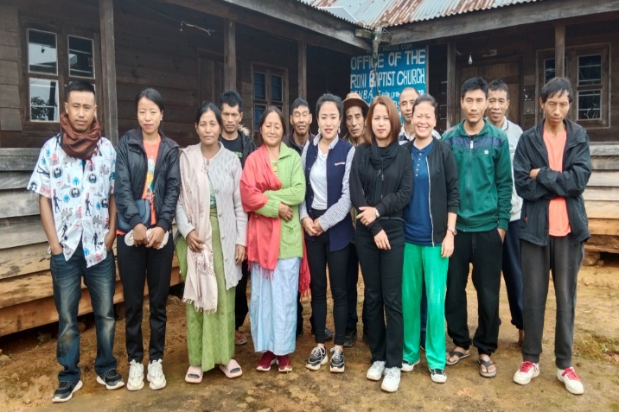
- Community Capacitation
ADCC Meeting at Ngahui

ADCC Meeting at Roni
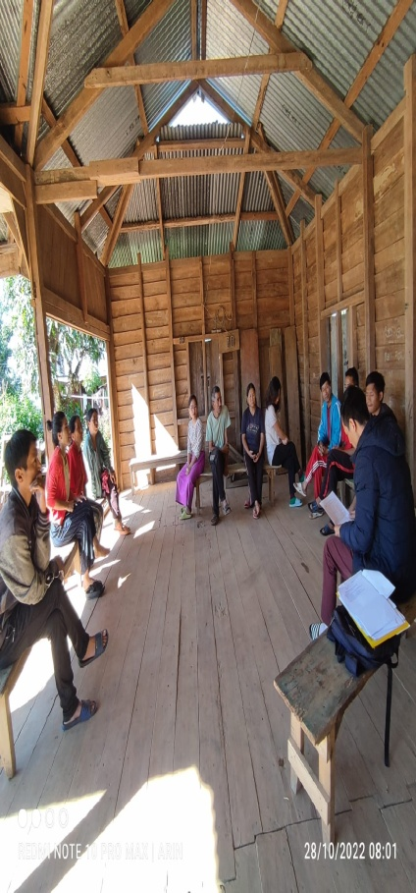
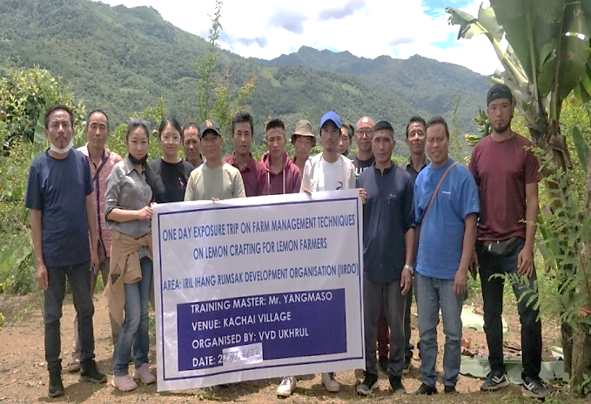

Training on Grafting of Lemon saplings at Kachai
Collection of Baseline Data at Punge
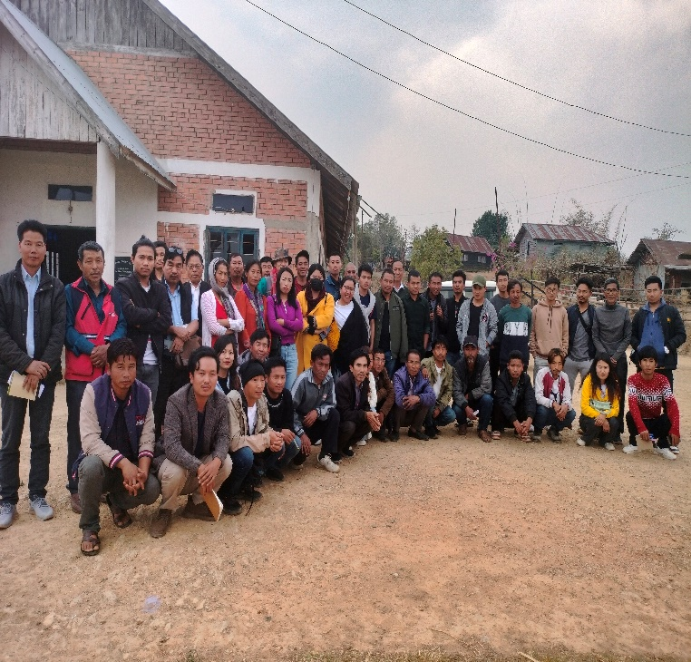
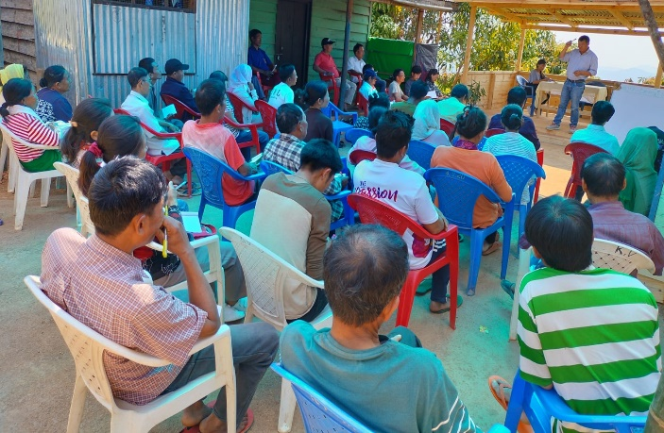

Workshop on strengthening Management of Natural Resources at Khambi
Pest and Diseases management of Fruit trees at Kumram

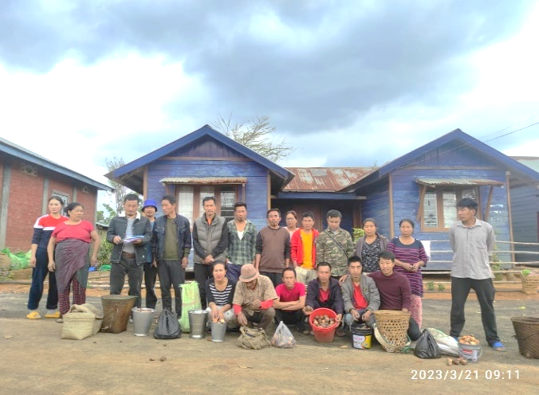
- Livelihood
Fruit sapling distribution at Roni and Kumram
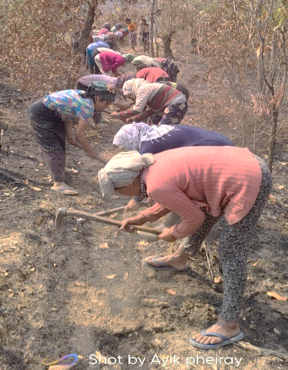
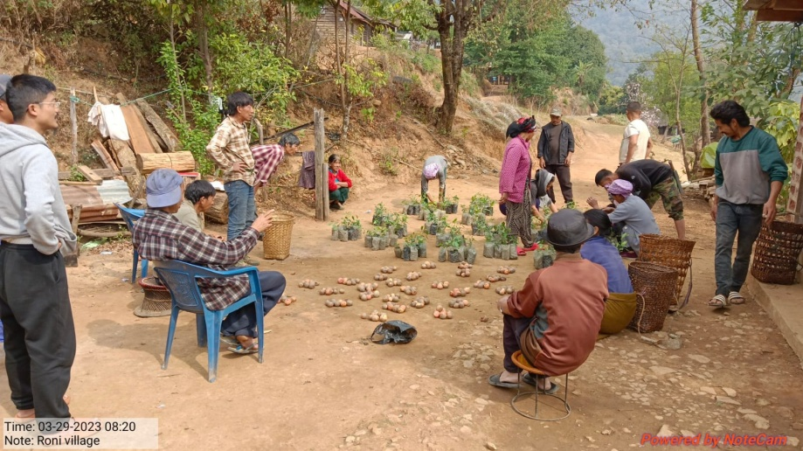

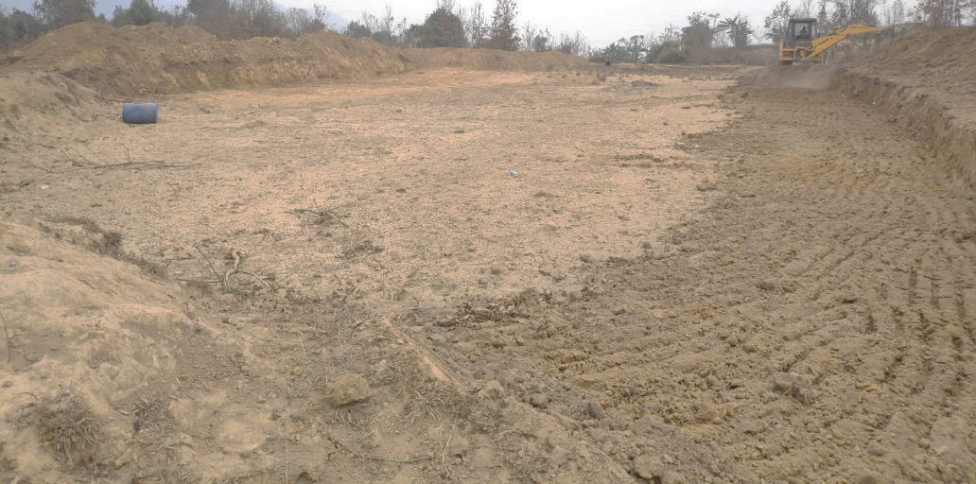

Land Development at Chinjaroi Khullen

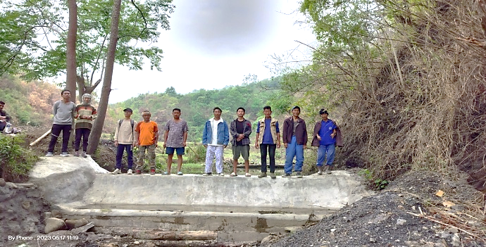
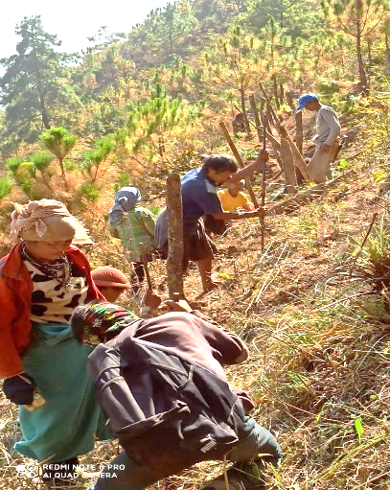

Minor irrigation at Hoomi
Farm Fencing at Zingsui

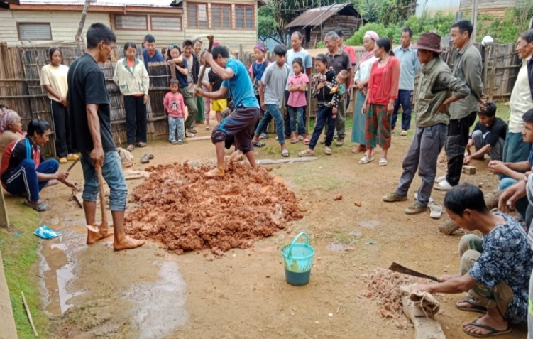
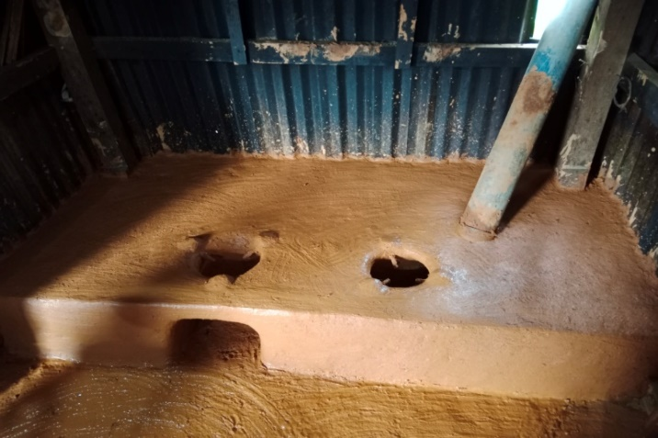
- Natural Resource Management
Construction of Chulha at Mapum

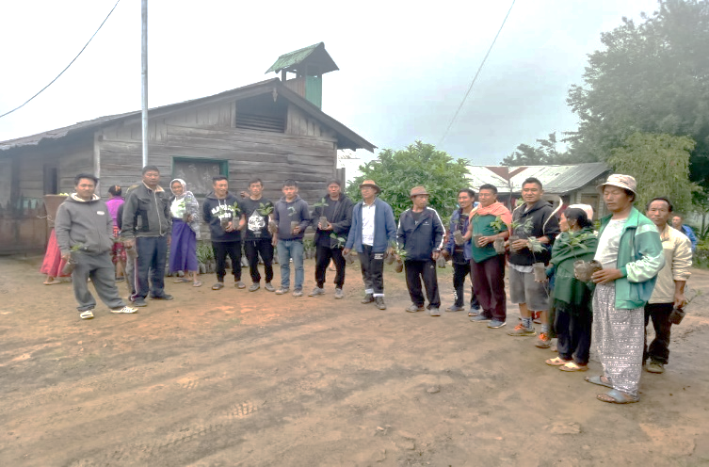
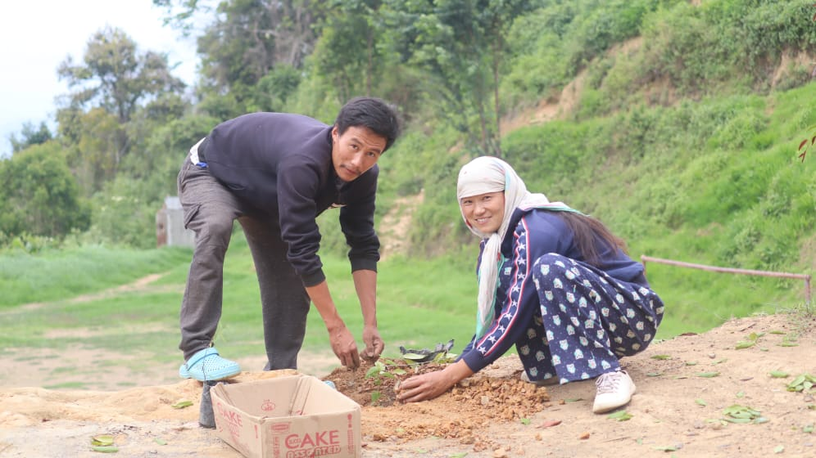
Community Tree Plantation at Chingjaroi

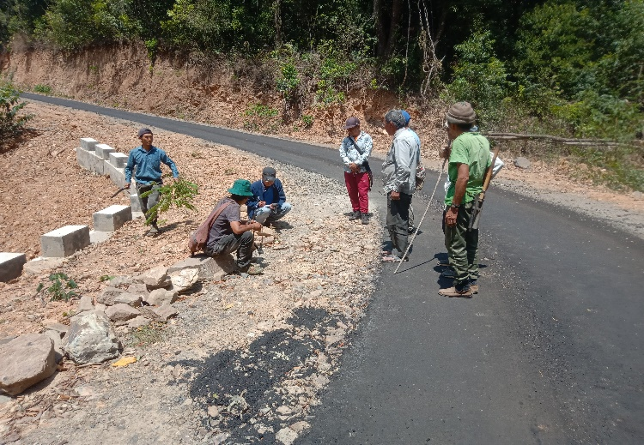
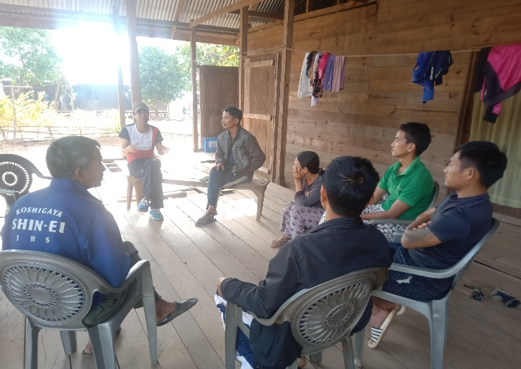
- Conflict mitigation

GPS Mapping at Punge and Patbung

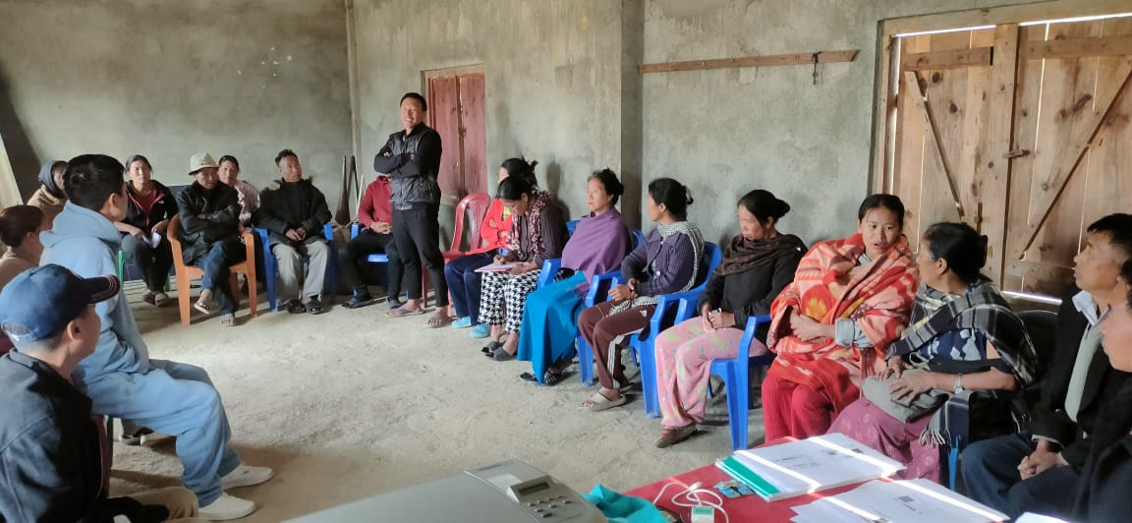
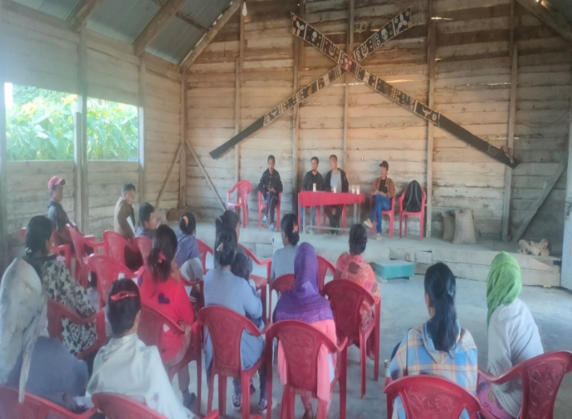
- Springshed program
Meeting with project beneficiaries at Kalhang and Kuirei
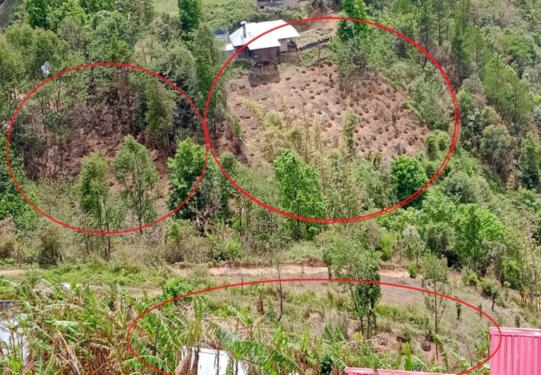
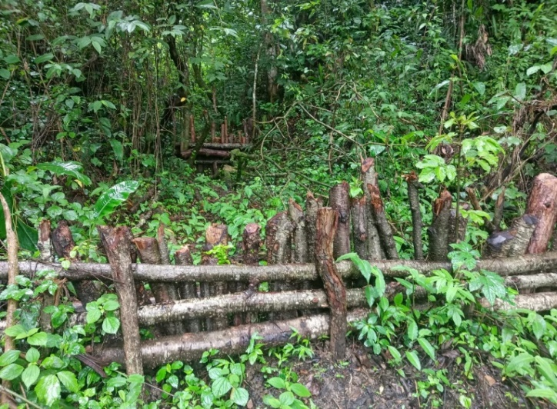
Staggered contour trenches at Kalhang and brushwood at Ngahui

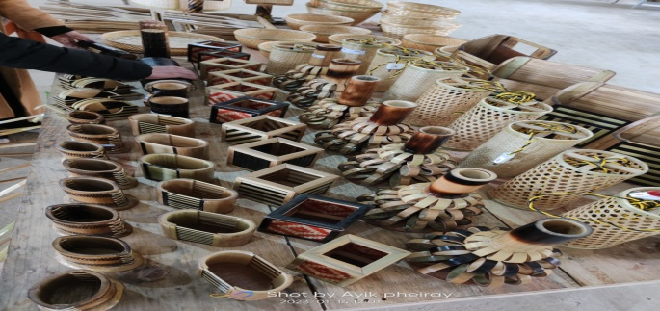
- Cane and Bamboo Handicraft
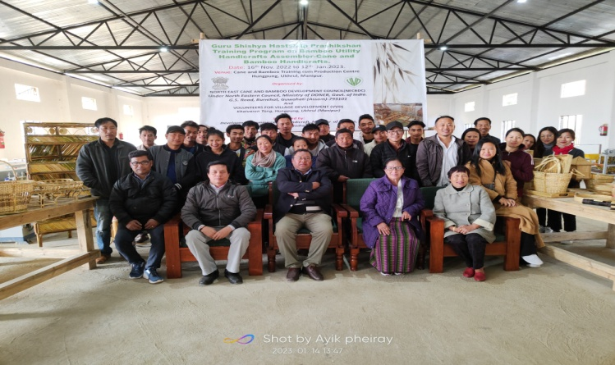
Training on Cane and bamboo handicraft at VVD training centre

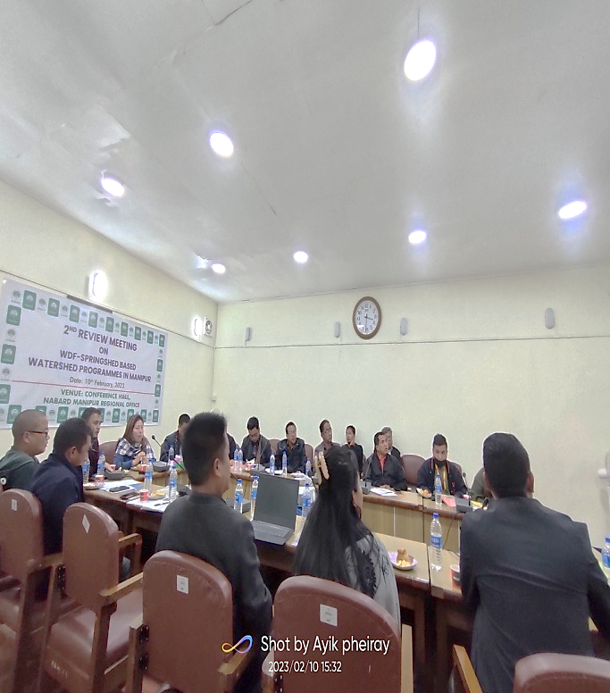
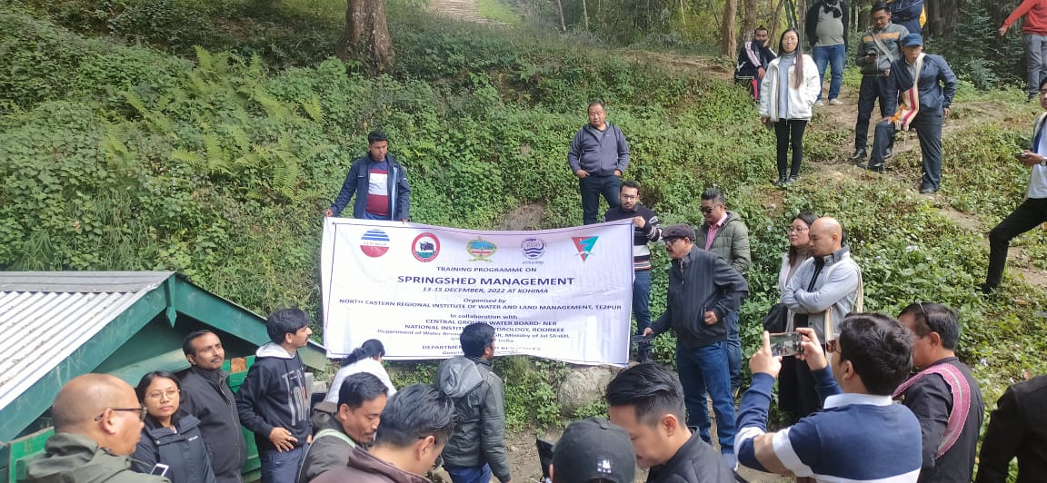
- Organizational Development
State Level workshop on Springshed at Kohima
Regional Meeting on Springshed at Imphal

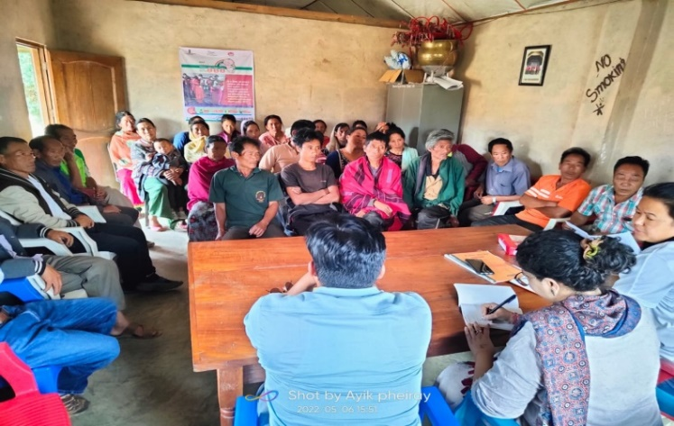
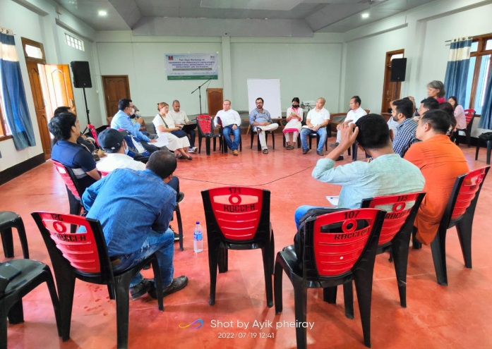

Project Evaluation at Ngachaphung
Meeting with Azim Premji Foundation at Imphal

Funding Partners
- Bftw, Germany
- Romanian Pentecostal Church, US
- NABARD, India
- NECBTC, India

